# Impact of the 2014-16 marine heatwave on U.S. and Canada West Coast fisheries: surprises and lessons from key case studies

Christopher M. Free1,2*, Sean C. Anderson3, Elizabeth A. Hellmers4, Barbara A. Muhling5,6, Michael O. Navarro7, Kate Richerson8, Lauren A. Rogers9, William H. Satterthwaite10, Andrew R. Thompson5, Jenn M. Burt11, Steven D. Gaines1,2, Kristin N. Marshall12, J. Wilson White13, Lyall F. Bellquist14,15

1 Bren School of Environmental Science and Management, University of California, Santa Barbara, Santa Barbara, CA

2 Marine Science Institute, University of California, Santa Barbara, Santa Barbara, CA

3 Pacific Biological Station, Fisheries and Oceans Canada, Nanaimo, BC, Canada

4 California Department of Fish and Wildlife, Marine Region, La Jolla, CA

5 National Marine Fisheries Service, Southwest Fisheries Science Center, La Jolla, CA

6 Institute of Marine Sciences, University of California Santa Cruz, Santa Cruz, CA

7 Department of Natural Sciences, University of Alaska Southeast, Juneau, AK

8 National Marine Fisheries Service, Northwest Fisheries Science Center, Newport Field Station, Newport, OR

9 National Marine Fisheries Service, Alaska Fisheries Science Center, Seattle, WA

10 National Marine Fisheries Service, Southwest Fisheries Science Center, Fisheries Ecology Division, Santa Cruz, CA

11 Nature United, North Vancouver, BC, Canada

12 National Marine Fisheries Service, Northwest Fisheries Science Center, Seattle, WA

13 Coastal Oregon Marine Experiment Station and Department of Fisheries, Wildlife, and Conservation Sciences, Oregon State University, Newport, OR

14 The Nature Conservancy, Sacramento, CA

15 Scripps Institution of Oceanography, University of California, San Diego, San Diego, CA

**\* Corresponding author:** Bren School of Environmental Science and Management, University of California, Santa Barbara, 2400 Bren Hall, Santa Barbara, CA 93106-5131; [cfree@ucsb.edu](mailto:cfree@ucsb.edu)

**Short running title:** Fisheries lessons from a marine heatwave

**Two alternative titles:**

* Impact of the 2014-16 Northeast Pacific marine heatwave on U.S. and Canada West Coast fisheries: surprises and lessons from key case studies
* Fisheries management under extreme events: Surprises and lessons from the 2014-16 Northeast Pacific marine heatwave

## Abstract

Marine heatwaves are increasingly affecting marine ecosystems, with cascading impacts on coastal economies, communities, and food systems. Studies of heatwaves provide crucial insights into potential ecosystem shifts under future climate change and put fisheries social-ecological systems through “stress tests” that expose both vulnerabilities and resilience. The 2014-16 Northeast Pacific heatwave was the strongest and longest marine heatwave on record and resulted in profound ecological changes that impacted fisheries management and human livelihoods. Here, we synthesize the impacts of the 2014-16 marine heatwave on U.S. and Canada West Coast fisheries and extract key lessons for preparing global fisheries science, management, and industries for the future. We set the stage with a brief review of the impacts of the heatwave on marine ecosystems and the first systematic analysis of the economic impacts of these changes on commercial and recreational fisheries. We then examine ten key case studies that provide instructive examples of the complex and surprising challenges that heatwaves pose to fisheries social-ecological systems. These reveal important insights into improving the resilience of monitoring and management and increasing adaptive capacity to future stressors. Key recommendations include: (1) expanding monitoring to enhance mechanistic understanding, provide early warning signals, and improve predictions of impacts; (2) increasing the flexibility, adaptiveness, and inclusiveness of management where possible; (3) using simulation testing to help guide management decisions; and (4) enhancing the adaptive capacity of fishing communities by promoting engagement, flexibility, experimentation, and failsafes. These advancements are important as global fisheries prepare for a changing ocean.

**Keywords:** climate change, climate-adaptive management, climate-resilient fisheries, ecological surprises, harmful algal blooms, ocean warming

## Table of Contents

1. Introduction

2. The 2014-16 marine heatwave (old long-form review here)

3. Socioeconomic impacts of the heatwave on fisheries

4. Case studies

4.1. Pacific cod

4.2. Kelp, urchin, abalone

4.3. Chinook salmon

4.4. Dungeness crab

4.5. Pacific sardine and northern anchovy

4.6. Pacific bluefin tuna

4.7. California market squid

4.8. Shrimp species

4.9. Bocaccio rockfish

4.10. Shortbelly rockfish

5. Lessons learned

5.1. Lessons for improving monitoring

5.2. Lessons for improving management

5.3. Lessons for improving adaptive capacity of fishing communities

5.4. Lessons for and from other regions

6. Conclusions

Acknowledgements

Data Availability Statement

Conflict of Interest Statement

References

Tables & Figures

Supplemental Information

## 1. Introduction

Marine heatwaves have increased in frequency, duration, and intensity over the last century [(Oliver et al., 2018)](https://www.zotero.org/google-docs/?mAk8BX) and are expected to become even more common and severe under climate change [(Frölicher et al., 2018; Laufkötter et al., 2020)](https://www.zotero.org/google-docs/?2nn2eK). These discrete and extended periods of warm water anomalies [(Hobday et al., 2016)](https://www.zotero.org/google-docs/?Xpr0qn) can greatly impact marine ecosystems [(Smale et al., 2019)](https://www.zotero.org/google-docs/?VZSy0o) with cascading impacts on coastal economies, communities, and food systems [(Smith et al., 2021)](https://www.zotero.org/google-docs/?qQwWMm). Learning from past heatwaves is essential to building resilience to both future heatwaves and to directional warming for two key reasons. First, conditions during heatwaves are a harbinger of the future and provide insights on what to expect and how to prepare. Second, heatwaves put management systems and livelihoods through a “stress test” that exposes vulnerabilities and opportunities for increasing resilience.

As of 2022, the 2014-16 heatwave in the Northeast Pacific was the strongest and longest marine heatwave in recorded history [(Laufkötter et al., 2020)](https://www.zotero.org/google-docs/?hiYbVZ). It lasted >700 days, spanned >2.5 million km2 at its largest extent, and sea surface temperatures were, on average, >2.0°C above the climatological mean [(Gentemann et al., 2017)](https://www.zotero.org/google-docs/?wsv9xp). The heatwave occurred in one of the best monitored and managed regions of the world [(Gallo et al., 2022; Hilborn et al., 2020; Melnychuk et al., 2021)](https://www.zotero.org/google-docs/?tWOpI2), yet still greatly affected marine ecosystems and economies [(Cavole et al., 2016)](https://www.zotero.org/google-docs/?ENwHZb). For example, the heatwave caused (1) the loss of kelp forests and the abalone and urchin fisheries that depend on kelp [(Rogers-Bennett & Catton, 2019)](https://www.zotero.org/google-docs/?gCJhEg); (2) an unprecedented harmful algal bloom that resulted in coastwide shellfish fishery closures [(McCabe et al., 2016)](https://www.zotero.org/google-docs/?oWXRLs); (3) a spike in humpback whale (*Megaptera novaeangliae*, Balaenopteridae) entanglements resulting from increased overlap of whale foraging grounds with the Dungeness crab (*Metacarcinus magister*, Cancridae) fishery [(Santora et al., 2020)](https://www.zotero.org/google-docs/?KWDqps); and (4) recruitment failures for several fishery species [(Laurel & Rogers, 2020; McClatchie et al., 2016)](https://www.zotero.org/google-docs/?BJxKpJ). Learning from these impacts can bolster the resilience of monitoring programs, management systems, and fishing communities to the negative impacts of future heatwaves and climate change.

The heatwave also benefited many species [(Cavole et al., 2016)](https://www.zotero.org/google-docs/?lqaSk3), which present their own unique management challenges. For example, an explosion in the abundance of shortbelly rockfish (*Sebastes jordani*, Sebastidae) in Oregon, a non-target bycatch species, required rapid management action to avoid the closure of the Pacific hake (*Merluccius productus*, Merlucciidae) fishery, which nearly exceeded its bycatch limit within the first two weeks of the season [(NMFS, 2020)](https://www.zotero.org/google-docs/?uHe5DS). Similarly, the northward expansion of California market squid (*Doryteuthis opalescens*, Loliginidae) [(Chasco et al., 2022)](https://www.zotero.org/google-docs/?iRosT4) required rapid management action to regulate the newly emerging fishery in northern latitudes [(ODFW, 2021)](https://www.zotero.org/google-docs/?BUyaH9). In addition, movement of large Pacific bluefin tuna (*Thunnus orientalis*, Scombridae) into U.S. waters during the heatwave was a boon for recreational fishing [(Runcie et al., 2019)](https://www.zotero.org/google-docs/?lgAf5n). However, it increased fishing mortality on this already overfished stock and highlighted an incomplete understanding in the relationship between local availability and stockwide abundance. Flexible, agile, and informed management is thus crucial to preparing coastal communities for both positive and negative climate impacts.

Here, we synthesize the impacts of the 2014-16 marine heatwave on fishing communities along the West Coast of the United States and Canada and extract key lessons for preparing fisheries science, management, and industries for future climate change and heatwaves based on this experience. We set the stage with a brief review of the impacts of the heatwave on the ecosystem and the first systematic analysis of the economic impacts of these changes on commercial and recreational fisheries. This analysis examines the change in commercial fisheries revenues and recreational fisheries landings that occurred during and after the heatwave relative to before the heatwave. We then examine ten key case studies that provide instructive examples of the complex and surprising challenges that heatwaves pose to fisheries social-ecological systems. These reveal important insights into improving the resilience of monitoring, management, and adaptive capacity to future stressors.

## 2. The 2014-16 marine heatwave

The marine heatwave began in fall 2013 as a large “blob” of anomalously warm water in the Gulf of Alaska (**Figure 1**) [(Bond et al., 2015)](https://www.zotero.org/google-docs/?11M836). This warm water pool formed as a result of an unusually persistent ridge of high atmospheric pressure that reduced storminess, weakened surface winds, intensified stratification, and reduced both heat loss to the atmosphere and advection of cooler water into the upper ocean [(Bond et al., 2015)](https://www.zotero.org/google-docs/?u8iLD0). In spring 2014, a separate upper ocean warm pool developed in the distant southern California Current ecosystem, associated with reduced alongshore wind and coastal upwelling. By fall 2014, these two warm water anomalies merged, encompassing much of the Northeast Pacific [(Di Lorenzo & Mantua, 2016)](https://www.zotero.org/google-docs/?Sfkmqi). The heatwave persisted as a result of a strong El Niño that began in mid-2015 and caused warm conditions to last until summer 2016 in the California Current [(Di Lorenzo & Mantua, 2016; Jacox et al., 2016)](https://www.zotero.org/google-docs/?gZZfS8) and through 2017 in the Gulf of Alaska [(Suryan et al., 2021)](https://www.zotero.org/google-docs/?PGfOfu). Throughout this period, anomalously warm conditions only abated in spring in nearshore upwelling zones during periods of favorable wind stress [(Gentemann et al., 2017)](https://www.zotero.org/google-docs/?3OOXpg). However, cool, nutrient-rich, subarctic source water was locally available before and during the heatwave [(Schroeder et al., 2019)](https://www.zotero.org/google-docs/?P6wOOS). During the southern warming event, weakened winter storms and upwelling-favorable alongshore winds resulted in persistent stratification of the surface layer. This limited the vertical mixing of cold, nutrient-rich, deep water into surface waters, leading to reduced nutrient fluxes into the euphotic zone and deepening of the nutricline in 2014-15 [(Zaba & Rudnick, 2016)](https://www.zotero.org/google-docs/?9l5FKi).

These physical changes had profound impacts on plankton communities throughout the California Current ecosystem. In nearshore waters, enhanced stratification reduced nutrient renewal, leading to low phytoplankton abundance [(Delgadillo-Hinojosa et al., 2020; Peña et al., 2019)](https://www.zotero.org/google-docs/?CnD8Fc). However, in offshore waters, increased stratification increased effective light levels in the surface layer and increased production in an area normally co-limited by iron and light [(Peña et al., 2019)](https://www.zotero.org/google-docs/?PNOR5W). These conditions contributed to a harmful algal bloom of unprecedented size, duration, and intensity, leading to widespread fishery closures and contributing to mass mortalities of seabirds and marine mammals [(McCabe et al., 2016; McKibben et al., 2017)](https://www.zotero.org/google-docs/?gyh8Cv). The bloom, composed of diatoms in the *Pseudo-nitzschia* genus (Bacillariaceae), was induced through a perfect storm of events. First, anomalously warm conditions allowed *Pseudo-nitzschia*, which is tolerant to low nutrient levels, to thrive in warm, nutrient-poor, offshore waters north of its typical range. Then, a series of seasonal storms transported the offshore bloom to the coast, where seasonal upwelling injected nutrients that further intensified the bloom [(McCabe et al., 2016)](https://www.zotero.org/google-docs/?0qyxI5). As for the zooplankton community, abundance remained high throughout the heatwave, but with dramatic changes in composition. In general, there was a surge in warm-water species from southern and offshore waters, an increase in the abundance of gelatinous zooplankton, and a decrease in the abundance of crustacean holoplankton, particularly krill [(Batten et al., 2022; Brodeur et al., 2019; Lilly & Ohman, 2021; McKinstry et al., 2022; Peterson et al., 2017; Thompson, Ben-Aderet, et al., 2022)](https://www.zotero.org/google-docs/?FeYKtr). The dominance of lipid-poor warm-water zooplankton relative to lipid-rich cool-water zooplankton likely contributed to lower productivity in higher trophic levels [(Peterson et al., 2017)](https://www.zotero.org/google-docs/?zWLqce).

The heatwave induced many changes to higher trophic-level species. In general, the ranges of southern warm-water fish and large invertebrates extended northward, and the ranges of offshore warm-water species extended inshore as waters warmed coastwide [(Thompson, Ben-Aderet, et al., 2022)](https://www.zotero.org/google-docs/?iotEGF). Interestingly, many cool-water species generally appeared to persist within their historical geographic ranges, likely due to the presence of pockets of cool water [(Sanford et al., 2019)](https://www.zotero.org/google-docs/?XxBoDj). The heatwave also induced shifts, both positive and negative, in the productivity of many ecologically and economically important fish species [(Cavole et al., 2016)](https://www.zotero.org/google-docs/?FySduY). For example, while rockfish (*Sebastes* spp., Sebastidae) and Northern anchovy (*Engraulis mordax*, Engraulidae) recruitment was high during the heatwave, Pacific sardine (*Sardinops sagax*, Clupeidae) and salmon recruitment was low [(Munsch et al., 2022; Schroeder et al., 2019; Thompson, Ben-Aderet, et al., 2022)](https://www.zotero.org/google-docs/?nu4iOz); hypothesized mechanisms are discussed in greater detail in the case studies below. Furthermore, the heatwave reduced the nutrient content of key forage fish species as result of shifts in the availability of their prey [(Mantua et al., 2021; von Biela et al., 2019)](https://www.zotero.org/google-docs/?DRnyOX). In some cases, changes in the abundance, composition, and nutrient content of forage fish triggered the mass mortality of marine mammals [(NMFS, 2022)](https://www.zotero.org/google-docs/?4ximDV) and seabirds [(Drever et al., 2018; Jones et al., 2018, 2019; Piatt et al., 2020)](https://www.zotero.org/google-docs/?ixJapz). In other cases, high recruitment of anchovy and other fishes during the marine heatwave fueled marine mammals and seabird population growth that have persisted to at least 2021 [(Thompson, Ben-Aderet, et al., 2022)](https://www.zotero.org/google-docs/?aBXyLI).

## 3. Socioeconomic impacts of the heatwave on fisheries

The socioeconomic impacts of the heatwave on commercial, recreational, and Indigenous fisheries are documented for some high profile fisheries suffering large negative impacts, but have not been systematically quantified for the majority of the coast’s fisheries. In the United States, federal fisheries disasters were declared as a result of the heatwave for commercial and Indigenous fisheries targeting Dungeness crab and rock crab (*Cancer* spp., Cancridae), Pacific sardine, red sea urchin (*Mesocentrotus franciscanus*, Strongylocentrotidae), and many salmon stocks (**Figure 2**), resulting in over US$141 million in relief to impacted fishers, processors, and dealers [(Bellquist et al., 2021)](https://www.zotero.org/google-docs/?PWtXwm). Among these disaster declarations, the largest appropriation (US$56.3 million) was to the Gulf of Alaska pink salmon (*Oncorhynchus gorbuscha*, Salmonidae) industry following low salmon returns attributed to poor oceanographic conditions [(Pritzker, 2017a)](https://www.zotero.org/google-docs/?Xmgc1f). The second largest appropriation (US$25.8 million) was to the California Dungeness crab industry following extended fishery closures due to harmful algal blooms [(Pritzker, 2017b)](https://www.zotero.org/google-docs/?BODO1z). Amongst recreational fisheries, negative economic impacts are best documented for razor clams (*Siliqua patula*, Pharidae) [(Ekstrom et al., 2020; Moore et al., 2019; Ritzman et al., 2018)](https://www.zotero.org/google-docs/?GZJaCj), which support large tourist economies in Oregon and Washington [(Dyson & Huppert, 2010)](https://www.zotero.org/google-docs/?FyEebi). The 2015 harmful algal bloom caused widespread closures in both states causing an estimated loss of US$22 million in tourism revenues [(Mapes, 2015)](https://www.zotero.org/google-docs/?rVC23k). In addition to causing increased financial hardship, these events contributed to increased emotional stress and reduced sociocultural well-being [(Moore et al., 2020)](https://www.zotero.org/google-docs/?t0qHxO).

To provide the first systematic overview of the potential economic impacts of the heatwave on the commercial fisheries of the U.S. and Canada West Coast, we compared revenues during (2014-2016) and after the heatwave (2017-2019) with revenues before the heatwave (2011-2013) using commercial landings data (see supplemental information). To account for inflation, we adjusted all revenues to 2020 U.S. dollars. This analysis is limited in that it cannot attribute causality, it does not account for lags in heatwave impacts (which may be minimal for range shifts or for especially fast-lived species, or delayed for species that recruit into the fishery at age 2 or older; [White et al., 2022)](https://www.zotero.org/google-docs/?VWrTYw), and it assumes that profits are proportional to revenues, but it still provides useful insights into the identity and rank order of potential heatwave “winners” and “losers”. We found that fleetwide revenues fell during the heatwave in California and Alaska, were stable in Oregon and Washington, and increased in British Columbia. The largest decreases occurred in California (**Figure 3A**), largely due to exceptionally high revenue losses in California’s Dungeness crab, Pacific sardine, and market squid fisheries (**Figure 3B)**. Whereas a small dip in revenues rebounded to pre-heatwave levels in Oregon and Washington, revenues remained low in both Alaska and California throughout the three years following the heatwave (**Figure 3A**). British Columbia experienced higher revenues after the heatwave than in either the periods before or during the heatwave, largely driven by increases in revenues from coastal pelagic species. All four U.S. states saw revenue losses in coastal pelagic fisheries and significant revenue increases in shrimp fisheries during the heatwave. Only California saw increases in revenues in fisheries for highly migratory species during the heatwave, and only Oregon saw increases in revenues from bivalve fisheries (**Figure 3B).** Among management groups with reduced revenues during the heatwave, recovery to pre-heatwave revenues only occurred in Oregon and Washington’s Dungeness crab fisheries and British Columbia’s salmon fisheries. Species-specific results show an array of winners and losers, illustrating the complex heterogeneity of heatwave impacts (**Figure S1**).

We performed a similar analysis on recreational fisheries landings using estimates of the number of fish retained across all fishing modes (e.g., charter/private boats, jetties, piers, beaches, etc.) (see supplemental information). Recreational fisheries are significantly larger in California than in British Columbia or the other U.S. states (**Figure 4**). Overall, recreational landings in California declined during and after the heatwave, though this may be part of a longer-term trend (**Figure 4A**). Declines during the heatwave were driven by large declines in coastal pelagic species (e.g., sardine, anchovy), flatfish, and other miscellaneous species and were only slightly offset by large increases in tuna, roundfish (e.g., sablefish, hake, cod), surfperch, and rockfish (**Figure 4B**). Overall, recreational landings in Oregon, Washington, and Alaska have been relatively constant through time and even increased during the heatwave (**Figure 4A**). In these states, increased landings were apparent in every species group except sharks and rays and the “other fish” category (**Figure 4B**). As with commercial fisheries revenues, species-specific results show a diversity of impacts (**Figure S2**).

Indigenous fisheries in the Pacific Northwest are especially vulnerable to climate change [(Koehn et al., 2022)](https://www.zotero.org/google-docs/?J91hb6) and they were likely disproportionately impacted by the heatwave. Although limited information on Indigenous landings and revenues in public databases precludes impact analyses like those above, U.S. federal fishery disaster declarations provide some indication of the socioeconomic impacts of the heatwave on Native American fisheries (First Nation fisheries are not considered because Canada does not have an analogous disaster relief program). Tribal fishery disaster declarations, primarily occurring among salmon fisheries, significantly increased beginning in 2017 as the impacts of the heatwave were fully realized [(Bellquist et al., 2021)](https://www.zotero.org/google-docs/?5OkjIS). Fifteen individual tribes and four tribal associations representing ~200 tribes across the Pacific Northwest and Alaska were impacted by these disasters [(Bellquist et al., 2021)](https://www.zotero.org/google-docs/?FvJiMY). Overall, US$111-188 million was appropriated to tribal fishing communities as a result of the heatwave. However, disaster declarations do not fully capture impacts to Indigenous fisheries, which provide significant sociocultural and subsistence values [(Crosman et al., 2019)](https://www.zotero.org/google-docs/?xFk1Z9). More cooperative research is necessary to characterize the impacts of climate change and heatwaves on Indigenous communities and to identify and implement actions for bolstering their resilience to these impacts [(Mason et al., 2022)](https://www.zotero.org/google-docs/?QGunMp).

## 4. Case studies

In this section, we present ten key case studies that provide instructive examples of the complex and surprising challenges that heatwaves pose to fisheries social-ecological systems and reveal important insights into improving the resilience of monitoring, management, and adaptive capacity to future stressors (**Figure 5**). These case studies represent a diversity of management regimes (international, federal, state), sectors (commercial, recreational, Indigenous), and taxonomic groups (finfish, crabs, shrimp, squid, abalone, urchins). Case studies were selected to describe both positive and negative heatwave impacts. The five case studies focused on negative impacts are all fisheries that received U.S. federal disaster relief as a result of the heatwave: Pacific cod (*Gadus macrocephalus*, Gadidae), urchin/abalone, Chinook salmon (*Oncorhynchus tshawytscha*, Salmonidae), Dungeness crab, and Pacific sardine. The five case studies focused on positive impacts were selected based on common examples from the literature (Pacific bluefin tuna, California market squid, two rockfish species; see Cavole et al. 2016) and a prominent example from this study’s data analysis (shrimp). In each case study, we provide a brief overview of the fishery, the impact of the heatwave on the fishery, the response of industry and management to these impacts, and the revealed opportunities for improving resilience to future heatwaves and climate change.

### 4.1. Pacific cod

Pacific cod has long supported a productive commercial fishery in the Gulf of Alaska. However, in 2017, a sudden and severe decline in biomass was detected that could not be explained by harvest alone [(Barbeaux et al., 2021)](https://www.zotero.org/google-docs/?jn0X6W). Rather, the stock experienced the double impact of increased adult mortality and sustained low recruitment due to the heatwave. High mortality of adult cod was associated with poor body condition [(Barbeaux et al., 2020)](https://www.zotero.org/google-docs/?dBY8I4) due to reduced prey availability and increased metabolic demands during the heatwave [(Piatt et al., 2020; Rogers et al., 2021; von Biela et al., 2019)](https://www.zotero.org/google-docs/?rtfjl9). Simultaneously, warm water at depth likely reduced egg survival and recruitment [(Laurel & Rogers, 2020)](https://www.zotero.org/google-docs/?sbAMJv). Heatwave conditions returned in 2019, further depressing recruitment and delaying recovery of the stock. Despite severe reductions to catch limits for 2018 and 2019 in response to these declines, declines continued, leading the North Pacific Fisheries Management Council to close the directed federal Pacific cod fishery for 2020 [(Barbeaux et al., 2021)](https://www.zotero.org/google-docs/?k79L1e) (**Figure 6B**). Impacts to fishing communities were significant, leading to a federal fisheries disaster declaration. By 2022, the stock was increasing, but catch limits remained a small fraction of pre-heatwave levels. The management response to the dramatic stock declines reflects the system of ecosystem-based fisheries management in Alaska and highlights lessons for fisheries management under rapidly changing environmental conditions. First, precautionary buffers, which reduce catch limits from the maximum allowable, can be used when ecosystem conditions raise red flags for a stock that are not captured in the stock assessment process [(Dorn & Zador, 2020)](https://www.zotero.org/google-docs/?y96aju). Continued incorporation of ecosystem information into the management process can allow managers to respond precautionarily, but requires effective monitoring and research to be most effective [(Peterson Williams et al., 2022)](https://www.zotero.org/google-docs/?8PleM2). Second, a forward-looking perspective is needed: for instance, recruitment projections based on historical observations and relationships become less informative when applied to unprecedented ocean conditions [(Litzow et al., 2021)](https://www.zotero.org/google-docs/?SWEOP6). Early warning indicators can enable proactive management in the case of rapid ecosystem or stock shifts [(Litzow et al., 2022)](https://www.zotero.org/google-docs/?1LxKr2). Finally, climate-linked stock assessment approaches [(Barbeaux et al., 2021)](https://www.zotero.org/google-docs/?yJIOvo) will be important for proactively responding to future heatwaves and other extreme events.

### 4.2. Kelp, urchin, abalone

In 2015, a perfect storm of stressors tipped bull kelp (*Nereocystis luetkeana*, Laminariaceae) forests in northern California into unproductive urchin barrens, ultimately causing the collapse of the recreational abalone and commercial urchin fisheries, both of which are kelp herbivores [(Rogers-Bennett & Catton, 2019)](https://www.zotero.org/google-docs/?CDfWIm). This began in summer 2013 when Sea Star Wasting syndrome caused a massive die-off of sunflower sea stars (*Pycnopodia helianthoides*, Asteriidae), an important predator of urchins in kelp forest ecosystems [(Harvell et al., 2019)](https://www.zotero.org/google-docs/?tzDPHZ). Then, in 2014, warm waters and nutrient limitation suppressed kelp growth and spore production, reducing productivity [(Rogers-Bennett & Catton, 2019)](https://www.zotero.org/google-docs/?31uXCg). As a result of reduced productivity and increased urchin grazing pressure following predation release, bull kelp forests were reduced by >90% along the northern California coast [(McPherson et al., 2021; Rogers-Bennett & Catton, 2019)](https://www.zotero.org/google-docs/?tiRwNK). In 2015, the loss of kelp forage resulted in the collapse of the commercial red sea urchin fishery. While the abundance of red sea urchins, which are marketed for their roe, remained high, starvation due to lack of kelp led to poor gonad production and unmarketable urchins. This collapse was declared a federal fisheries disaster and $3.3 million in disaster relief was distributed to impacted fishers, processors, and dealers [(Bellquist et al., 2021)](https://www.zotero.org/google-docs/?Fd3KTb). In 2017, the mass mortality of red abalone (*Haliotis rufescens*, Haliotidae) due to starvation (kelp is their primary food source) led to the closure of the recreational abalone fishery in California and Oregon (**Figure 6C**), which previously supported ~35,000 participants and the infusion of $24-44 million into local economies annually [(Reid et al., 2016)](https://www.zotero.org/google-docs/?txYP6b). The fishery remains closed at the time of writing (Jan 2023). Active recovery facilitated by reductions in urchin grazing pressure and enhancements to kelp growth could increase the resilience of kelp forests and the fisheries they support to climate change [(Hamilton et al., 2022; Hohman, 2019)](https://www.zotero.org/google-docs/?DCgge1). The first could involve encouraging new fisheries for purple sea urchin (*Strongylocentrotus purpuratus*, Strongylocentrotidae), which are less attractive than red urchins because they are smaller, have smaller gonads (the marketed product), and require more effort to harvest and process [(Parker & Ebert, 2003)](https://www.zotero.org/google-docs/?fApxkz). The latter might involve area-based protection or active restoration through seeding [(Arroyo-Esquivel et al., 2022)](https://www.zotero.org/google-docs/?Yah0De); however, restoration is expensive and may require developing new strategies to finance the restoration of these ecosystems [(Eger et al., 2020)](https://www.zotero.org/google-docs/?SVh0eX).

### 4.3. Chinook salmon

Chinook salmon range from central California to Alaska and support Indigenous, commercial, and recreational fisheries of considerable economic [(Richerson et al., 2018)](https://www.zotero.org/google-docs/?UR6iBu), subsistence [(Poe et al., 2015)](https://www.zotero.org/google-docs/?2aiHmW), and cultural [(Campbell & Butler, 2010)](https://www.zotero.org/google-docs/?6w1pfW) value. The Sacramento and Klamath River Fall Chinook salmon stocks of southern Oregon are primarily regulated using harvest control rules based on forecasts of preseason abundance. In general, both forecast models are based on the previous year’s returns [(Peterman, 1982; Winship et al., 2015)](https://www.zotero.org/google-docs/?QzcNrf); they do not explicitly include environmental covariates, despite their known importance [(Friedman et al., 2019; Wells et al., 2016)](https://www.zotero.org/google-docs/?lZR05d), due partially to concerns about their long-term predictive power [(Wainwright, 2021; Winship et al., 2015)](https://www.zotero.org/google-docs/?XBz46q). The marine heatwave impacted juveniles entering the ocean in 2014-16, which means that the impacts of the heatwave were not realized until these cohorts returned as adults, primarily in 2016-19. During the return period, the models for each stock successfully forecasted low preseason abundance, but tended to overestimate the actual return size (**Figure 6D**). In the Klamath River, the 2016 run size was the lowest since 1983 and the 2017 run size was the third-lowest. In the Sacramento River, 2016 escapement was below average and 2017 escapement was the second-lowest since 1983. As a result, both stocks were declared overfished in 2018 and several federal fishery disasters were declared, impacting both commercial harvesters and Klamath Basin tribes. These disasters were attributed to the marine heatwave and simultaneous extreme drought conditions that resulted in warmer river temperatures and anomalously low water levels [(PFMC, 2019a, 2019b)](https://www.zotero.org/google-docs/?oONElP). While catch limits were adjusted downwards in response to low preseason abundance forecasts, they were not reduced as much as they would have been if the impacts of the heatwave and drought had been perfectly forecast. Thus, optimistic model forecasts and/or insufficiently precautionary control rules may have contributed to overharvest and the eventual overfished designation. This suggests that improved forecasts and control rules could ameliorate overharvest risk. However, even with perfect foresight, poor environmental conditions still lead to loss in commercial revenues, recreational fishing opportunities, and cultural and subsistence benefits in Indigenous fisheries [(O’Rourke, 2018; PFMC, 2018, 2019b)](https://www.zotero.org/google-docs/?zppTzf). This highlights the importance of incorporating additional precaution to account for uncertainty [(Satterthwaite & Shelton, 2023)](https://www.zotero.org/google-docs/?ce2xXi) and enhancing the resilience of the salmon production to all climate impacts (e.g., drought, flood, terrestrial heatwaves) through freshwater and estuarine habitat restoration [(Munsch et al., 2022; Sturrock et al., 2019)](https://www.zotero.org/google-docs/?0sAAyT). It also highlights the importance of increasing community resilience by, for example, promoting the ability to switch to alternative fisheries.

### 4.4. Dungeness crab

The Dungeness crab fishery is the U.S. West Coast’s most lucrative commercial fishery and is the primary source of income for a large proportion of fishers coastwide [(Fuller et al., 2017)](https://www.zotero.org/google-docs/?kMBNLy). Historically, this fishery has been managed profitably and sustainably by limiting harvest to large male crabs during a November-August season (Richerson et al., 2020). However, the heatwave significantly disrupted the fishery through two indirect pathways. First, the 2015-16 harmful algal bloom triggered widespread fishery closures due to unsafe levels of biotoxins in crabs (**Figure 6A**). Closures were especially harmful in California, where they delayed the traditional November season start to mid-April [(McCabe et al., 2016)](https://www.zotero.org/google-docs/?gpl9H3). As a result, the 2015-16 season was declared a federal fisheries disaster and $25.8 million in disaster relief was allocated to impacted fishers, processors, and dealers, though not until over three years later [(C. Bonham, personal communication, July 19, 2018)](https://www.zotero.org/google-docs/?oC2qX6). When indirect losses from other fisheries were included, the delay was associated with >$43 million in lost income [(Holland & Leonard, 2020)](https://www.zotero.org/google-docs/?yGtIYN). Second, these delays led the fishery to open when humpback whales were returning north, intensifying the overlap between nearshore fishing and migrating whales. This overlap was further exacerbated by the heatwave-induced nearshore compression of coastal upwelling, which caused spatial shifts in forage species availability (i.e., offshore krill abundance decreased while inshore anchovy abundance increased), leading to a dramatic spike in whale entanglements in crab pot lines [(Santora et al., 2020)](https://www.zotero.org/google-docs/?ms7EAy). This precipitated a lawsuit alleging that California’s management of the Dungeness crab fishery threatened endangered species and was non-compliant with the Endangered Species Act (CA-DOJ 2017). These events prompted an overhaul of California’s entanglement risk management program (CDFW 2020), which has implemented early closures in the last four fishing seasons (2018-19 to 2021-22) to reduce entanglement risk. This has been effective at reducing entanglements but at significant cost to fishers [(Seary et al., 2022)](https://www.zotero.org/google-docs/?ZJdtbx). Increasing the resilience of the Dungeness crab fishery could be advanced by: (1) expanding the spatial-temporal scale of biotoxin monitoring to enable surgical closures that protect public health with the least impacts on fishers [(Free, Moore, et al., 2022)](https://www.zotero.org/google-docs/?BaKbCo); (2) continuing to refine entanglement prevention strategies that are co-developed with stakeholders and are proven to be effective, robust or adaptable to changing conditions, and minimally impactful on fishers [(CDFW, 2020; Samhouri et al., 2021)](https://www.zotero.org/google-docs/?9qWbKl); (3) reforming the federal fisheries disaster program to provide fast, accurate, and equitable relief [(Bellquist et al., 2021)](https://www.zotero.org/google-docs/?w1rKXn); and (4) easing access to alternative fisheries as a means of diversifying fishing opportunities [(Oken et al., 2021)](https://www.zotero.org/google-docs/?3PIuny) and potentially escaping the “gilded trap” presented by the lucrative, yet volatile, Dungeness crab fishery [(Fisher et al., 2021)](https://www.zotero.org/google-docs/?YnzvJz).

### 4.5. Pacific sardine and northern anchovy

Pacific sardine and northern anchovy have historically been two of the most abundant and ecologically important forage species in the California Current. Populations of both species are characterized by highly variable “boom-and-bust” cycles, even in the absence of fishing [(McClatchie et al., 2018)](https://www.zotero.org/google-docs/?hFIcc1). For decades, this variability was believed to relate to basin-scale oceanographic regimes (e.g., the Pacific Decadal Oscillation), with warm conditions favoring sardine and cool conditions favoring anchovy [(Chavez et al., 2003; Lluch-Belda et al., 1991; Rykaczewski & Checkley, 2008)](https://www.zotero.org/google-docs/?BUWWO2), but recent patterns have challenged this correlation. Although it was predominantly cool from 1999-2013, anchovies were abundant during warm conditions from 2004-06 and remained scarce during the other cool years [(Sydeman et al., 2020)](https://www.zotero.org/google-docs/?s5GvHT). Moreover, the heatwave was expected to help recover the declining sardine population and curb growth in an increasing anchovy population; instead, sardine abundance continued to decline throughout the heatwave [(Nielsen et al., 2021)](https://www.zotero.org/google-docs/?c10Mtc), contributing to the closure of the directed fishery in 2015 (**Figure 6E**), while anchovy abundance rose to near record highs (**Figure S3**) [(Thompson, Ben-Aderet, et al., 2022)](https://www.zotero.org/google-docs/?J1dLmF). Although the environmental mechanisms driving fluctuations in sardine and anchovy abundance remain poorly resolved, [(Swalethorp et al., 2022)](https://www.zotero.org/google-docs/?suiiQ8) found that changes in larval anchovy diet explained a significant proportion of spawning stock biomass two years later. Shifting anchovy and sardine dynamics illustrate the risks of relying on historical statistical correlations to guide management decisions, as climate change increasingly results in no-analog conditions in ecosystems such as the California Current. Although anchovy do not support substantial fisheries, their high biomass inshore likely contributed to increased entanglements of humpback whales with crab fishing gear [(Santora et al., 2020)](https://www.zotero.org/google-docs/?zSr2hI), but also appears to have led to a trend of more and healthier sea lion pups since 2016 in the California Channel Islands [(Weber et al., 2021)](https://www.zotero.org/google-docs/?jrCOOw) and successful nesting of resident seabirds on Southeast Farallon Island (Fennie et al. in review). While the heatwave did not trigger the initial decline in sardine biomass, the lack of recovery of this species continued to cause loss of revenue for direct commercial fisheries, and for the live-bait fishery supporting recreational fishers [(PFMC, 2020)](https://www.zotero.org/google-docs/?ZQYenE). Successfully managing these species under future climate conditions will require a better understanding of the links between complex environmental changes (beyond temperature alone), foraging ecology, and productivity of the stock, and/or using management strategies that are robust to these dynamics and limit impacts on seabirds, marine mammals, and other protected species [(Siple et al., 2019)](https://www.zotero.org/google-docs/?jeHHOw).

### 4.6. Pacific bluefin tuna

Pacific bluefin tuna, targeted by recreational fisheries in both U.S. and Mexican waters, and by commercial fisheries primarily in Mexican waters, increased in availability and size during the heatwave [(Heberer & Lee, 2019; Runcie et al., 2019)](https://www.zotero.org/google-docs/?29oLfJ). For example, the proportion of annual recreational bluefin landings from Commercial Passenger Fishing Vessels (CPFVs) landings showed a shift to U.S. waters coinciding with the heatwave (**Figure 7A**). Before 2014, U.S. waters accounted for an average of 23% of annual CPFV bluefin landings, but accounted for an average of 75% of annual landings from 2014-2021. While this shift could partially be explained by regulatory shifts, such as when Mexico began enforcing restrictions against U.S. recreational vessels in 2012, the shift occurred later and offshore fishing by U.S. vessels was still allowed with a permit. Additionally, before the heatwave, the majority of bluefin were landed in warm summer months and were less than 2 years old [(ISC, 2020)](https://www.zotero.org/google-docs/?lInRIw). Since 2014, warm waters extended availability throughout the year and more large bluefin (many 4-6 year-olds) were landed [(James et al., 2021)](https://www.zotero.org/google-docs/?ifhf9t). This increase in size is supported by time series analyses of recreational bluefin tuna “trophy” sizes [(Bellquist et al., 2016)](https://www.zotero.org/google-docs/?tm7sJ1) (**Figure S4**). Furthermore, the heatwave drove dietary shifts that may have affected availability [(Portner et al., 2022)](https://www.zotero.org/google-docs/?qRFTMk). In 2015-16, bluefin diets abruptly switched to domination by pelagic red crabs (*Pleuroncodes planipes*, Munididae), coincident with the anomalous northward advection of this southern crustacean [(Cimino et al., 2021)](https://www.zotero.org/google-docs/?KTeeOQ). In 2016, bluefin also increased their consumption of anomalously abundant anchovies [(Thompson, Ben-Aderet, et al., 2022)](https://www.zotero.org/google-docs/?NaHjll). This switch towards more epipelagic prey may have increased the aggregation of bluefin near the surface, where they are more vulnerable to fishing. Increased availability and size drove interest in recreational trips targeting bluefin and provided substantial economic benefits to the CPFV fleet. This was especially beneficial given low numbers of albacore (*T. alalunga*, Scombridae), the traditional target for many vessels. Benefits for commercial vessels were limited given low quotas for this overfished stock [(ISC, 2020)](https://www.zotero.org/google-docs/?v2RC7d); in fact, increased availability introduced management challenges. In 2017, the U.S. exceeded its catch limit by more than 50 metric tons (mt) due to high local availability, increased purse seine effort, and a several day lag in catch reporting, resulting in the August closure of the fishery [(Laughlin, 2018)](https://www.zotero.org/google-docs/?vxP0GA). Mexico’s purse seine fishery also reached its harvest limits by July in both 2014 and 2015. This illustrates how locally increased abundance of species subject to strict harvest control rules can challenge fisheries management. Increasing the resilience of this highly migratory species will require improved understanding of bluefin ecology, distribution, and migratory movements to help managers better anticipate and respond to challenges posed by future change.

### 4.7. California market squid

The heatwave triggered significant range expansions and geographical shifts in the productivity of California market squid, a southern warm-water species, which have persisted beyond the heatwave years and resulted in emerging fisheries in sudden need of management. Historically, the range of market squid has been concentrated in California, where it supports one of the state’s largest and most valuable fisheries [(Free, Vargas Poulsen, et al., 2022)](https://www.zotero.org/google-docs/?wgGAMT). In the past, strong El Niño conditions have supported temporary (weeks long) extensions of market squid range as far north as the Gulf of Alaska, where waters are normally too cold for this warm-water species. However, the 2014-16 marine heatwave resulted in a pronounced northward shift that has persisted longer than ever recorded [(Burford et al., 2022; Chasco et al., 2022; M. Navarro, 2020)](https://www.zotero.org/google-docs/?7R8avI). From 2016-20, California’s landings fell by more than 50% relative to the previous 5 years, while Oregon’s landings increased by orders of magnitude (**Figure 7B**). During the same time period, squid observations increased throughout the Gulf of Alaska, with spawning seen as far as Kodiak Island [(M. O. Navarro et al., 2018)](https://www.zotero.org/google-docs/?lTvZEX) and adults seen as far as the Shumagin (East Aleutian) Islands [(Eiler, 2021)](https://www.zotero.org/google-docs/?V1IGmL). The development of a significant squid fishery in Oregon ignited demand for new regulations to reduce conflicts with other fishing gears (e.g., Dungeness crab pots), bycatch (e.g., Dungeness crab and salmon), and impacts on benthic habitats [(ODFW, 2021)](https://www.zotero.org/google-docs/?n4Fyhi). Similarly, a proposal for a new market squid fishery in Alaska was submitted in 2017 [(Peeler, 2018)](https://www.zotero.org/google-docs/?NYyfrd), but was not passed due to concerns over bycatch of Chinook salmon, which are declining in abundance. Similar proposals are likely to resurface as warming waters decrease the productivity of traditional target species [(Cheung & Frölicher, 2020)](https://www.zotero.org/google-docs/?H2rJQI) and increase the availability of market squid as a profitable alternative. This case study illustrates how managers will need to prepare for rapidly emerging fisheries that introduce novel conflicts between fisheries and between economic and conservation goals. While improved monitoring and forecasting may help, decisions will still need to be made on short notice and with limited data, especially for species with fast life histories like squid.

### 4.8. Shrimp species

In our systematic analysis of fisheries revenues, West Coast commercial shrimp fisheries showed one of the strongest and most consistent increases in revenues during the heatwave (**Figure 3**), but have received little attention in the scientific literature. Revenues of Pacific pink shrimp (*Pandalus jordani*, Pandalidae), the 5th most important U.S. West Coast fishery species in terms of revenues over the last decade and by far the most significant shrimp species [(PSMFC, 2021)](https://www.zotero.org/google-docs/?0Dnh4J), experienced an enormous spike in revenues in both Oregon and Washington in 2015 (**Figure 7C**). Similarly, ridgeback prawn (*Sicyonia ingentis*, Sicyoniidae) experienced a profound spike in revenues in California, the only state in which it is fished (**Figure 7C**). Spot prawn (*Pandalus platyceros*, Pandalidae) revenues increased throughout the heatwave, continuing growth observed since 2003 (**Figure 7C**). These increases were unexpected as Pacific shrimp are generally thought to experience low recruitment in warm years and to have low landings following El Niño events [(Groth et al., 2017; Groth & Hannah, 2018)](https://www.zotero.org/google-docs/?KyF1zk). Furthermore, jellies, which clog the bycatch reduction devices required in shrimp trawl nets, were highly abundant during the heatwave, requiring shrimpers to develop innovative methods for maintaining flow through nets [(Groth et al., 2017)](https://www.zotero.org/google-docs/?XO36wS). Ultimately, the 2015 revenue spike can be explained by record high prices, determined by global markets, with assistance from a strong cohort of 2-year-old shrimp from 2013 [(Groth et al., 2022)](https://www.zotero.org/google-docs/?YBw1OO). Although the Oregon Department of Fish and Wildlife identified revisiting the relationship between shrimp recruitment and environmental conditions as a top research priority [(Groth et al., 2017)](https://www.zotero.org/google-docs/?Aw0BuD), it also highlighted that continued monitoring and improved stock assessment are, perhaps, more important to near-term fisheries outcomes. In fact, improved monitoring and more frequent assessments may explain the apparent resilience of these stocks to climate change, as rapid observations and assessments may provide more useful decision-support information than climate-linked forecasts for short-lived species. This case study highlights that: (1) global markets and lagged population dynamics can potentially mitigate (or, in other situations, exacerbate) heatwave impacts; (2) innovation by fishermen can overcome some negative heatwave impacts; and (3) addressing climate impacts may not be the highest priority if there are more pressing concerns (e.g., improving stock assessments, especially for short-lived species).

### 4.9. Bocaccio rockfish

In British Columbia, Canada, bocaccio rockfish (*Sebastes paucispinis*, Sebastidae) are regularly caught by the commercial trawl fleet [(Starr & Haigh, 2022)](https://www.zotero.org/google-docs/?BdaPap). The stock experienced a prolonged decline in spawning biomass from 1935-2020, despite relatively low exploitation rates, due to sustained low recruitment and lower productivity than expected [(Starr & Haigh, 2022)](https://www.zotero.org/google-docs/?jHivSr) (**Figure 7D**). As a result, the Committee on the Status of Endangered Wildlife in Canada designated the stock as Threatened in 2002 and Endangered in 2013 [(COSEWIC, 2013)](https://www.zotero.org/google-docs/?6fUqOW). In response, management reduced allowable catch and introduced trip limits with priority access for First Nations and scientific surveys and the total mortality cap reached a low of 80 mt by 2016 [(DFO, 2022)](https://www.zotero.org/google-docs/?jNDdb6). The commercial fleet was largely successful in actively avoiding the species and averaged only 69 mt from 2015-19. However, by the late 2010s, increasing abundance of bocaccio began to significantly limit the ability for the fleet to avoid this “choke species” (i.e., a species with low quotas relative to other species in a multi-species fishery) and target other more common species [(Pawson, 2021)](https://www.zotero.org/google-docs/?FDFfiV). The 2019 stock assessment estimated a massive recruitment event in 2016 at 44 times average recruitment from the previous 85 years (**Figure 7D**), large enough to rebuild the stock above the limit reference point with 95% probability within four years [(DFO, 2020; Starr & Haigh, 2022)](https://www.zotero.org/google-docs/?aRjaWR). This recruitment may have been due to the heatwave-induced availability of oxygen-rich water at depth during gestation [(DFO, 2020; Starr & Haigh, 2022)](https://www.zotero.org/google-docs/?MqQquX). The 2021 stock assessment update estimated an even larger 2016 year class (47 vs. 25 million one-year olds in 2017) and a more rapid recovery with the stock in the “healthy zone” (>0.8BMSY) with 87% probability by 2022 and near 100% probability by 2024 [(DFO, 2021)](https://www.zotero.org/google-docs/?oZIrJg). Given this new science advice, management raised the bocaccio total mortality cap to 300 mt in 2020-21, 500 mt in 2021-22, and 1800 mt for 2022-23 [(DFO, 2022)](https://www.zotero.org/google-docs/?mnrDJb). However, First Nations raised concerns about the short-term harvest perspective implied by the rapidity of total allowable catch increases and the lack of inclusiveness in management decisions and suggested an approach that acknowledges long-term uncertainties about stock productivity and ecosystem needs [(CCIRA, 2022)](https://www.zotero.org/google-docs/?4mADyN). This case study is a success story in terms of the natural and unexpected rebuilding of an endangered fish stock, but highlights institutional challenges in responding rapidly to sudden increases in abundance of choke species, and raises questions about long-term management of stocks dependent on rare, environmentally driven recruitment events.

### 4.10. Shortbelly rockfish

Shortbelly rockfish are an important prey species for seabirds and marine mammals in the California Current, and a non-target bycatch species in the commercial rockfish and Pacific hake trawl fisheries. In 2018, an explosion in shortbelly rockfish abundance following high recruitment during the marine heatwave nearly caused the closure of the hake fishery. In 2001, the Pacific Fisheries Management Council (PFMC) established a catch limit for shortbelly rockfish based on the belief that a commercial fishery would develop [(Field et al., 2007)](https://www.zotero.org/google-docs/?luZQx7). Although a directed fishery did not emerge, catch limits remained in place. Historically, shortbelly bycatch in the hake fishery has not approached the limit, but this changed radically as a result of the heatwave. Within the first two weeks of the 2018 fishing season, the commercial hake fishery off Oregon encountered several shortbelly bycatch hotspots and came very close to exceeding the annual catch limit (**Figure 7E**). Without management intervention, the high catch of shortbelly rockfish threatened to shut down the hake fishery at the very beginning of its season. To make a rapid but informed decision, the PFMC examined recruitment estimates from NOAA’s Rockfish Recruitment and Ecosystem Assessment Survey [(Sakuma et al., 2015)](https://www.zotero.org/google-docs/?4UAtdN). They found that recruitment increased for most rockfish species during the heatwave and that shortbelly recruitment jumped an order of magnitude above other rockfish winners. This was likely due to the predominance of subarctic source water in upper depths (100-400 m) over the outer shelf-slope where many rockfish spawn; subarctic source water is generally cooler, fresher, and more oxygenated than other source waters and is correlated with high rockfish recruitment [(Schroeder et al., 2019)](https://www.zotero.org/google-docs/?oCVVCc). As the fastest-lived rockfish (i.e., fast growth, early age at maturity, high mortality; [Love et al., 2002)](https://www.zotero.org/google-docs/?FgzvNu), shortbelly rockfish were poised to benefit from these favorable conditions [(Field et al., 2007; Pearson et al., 1991)](https://www.zotero.org/google-docs/?lXFuUe). As a result of these massive recruitment events, shortbelly abundance was likely higher than it had been in decades. After considering this best available science and statements from advisory bodies and the public, the PFMC raised the catch limit for the 2018 season, saving the hake fishery from early closure. This case study highlights the importance of fishery-independent monitoring of all life stages for detecting and explaining ecological surprises and the importance of nimble and flexible management that is responsive to such surprises.

## 5. Lessons learned

### 5.1. Lessons for improving monitoring

The resilience of fisheries to heatwaves and climate change can be increased by improving the scale, utility, diversity, accessibility, and funding of monitoring programs. First, strategically enhancing the spatial-temporal scale of monitoring can promote dynamic management that reduces tradeoffs among competing management objectives. For example, increased spatial-temporal monitoring of harmful algal blooms and biotoxin contamination can protect public health while minimizing impacts on fishing opportunities [(Free, Moore, et al., 2022)](https://www.zotero.org/google-docs/?5gFAmt). Similarly, data generated from expanded monitoring enables the development of predictive models that can, for example, help to avoid bycatch of protected species under changing environmental conditions [(Hazen et al., 2018)](https://www.zotero.org/google-docs/?VZjeI9). Second, targeted monitoring is necessary to understand drivers of the surprising shifts that have occurred during past heatwaves and to use this knowledge to better prepare for future heatwaves. For instance, targeted monitoring is necessary to resolve the relationship between the local availability and stockwide abundance of highly migratory species (see the bluefin tuna case study) and the reasons for unexpected reversals in long-believed relationships between the environment and fisheries productivity (see the sardine and anchovy case study) [(Myers, 1998)](https://www.zotero.org/google-docs/?kdJwXz). Third, developing novel monitoring programs can accelerate the detection and understanding of sudden and/or unexpected shifts in productivity or distributions. By complementing existing fisheries-independent surveys with information derived from fisheries-dependent data, heatwave-driven shifts in abundance and distribution could be detected earlier and more comprehensively [(Hobday & Evans, 2013)](https://www.zotero.org/google-docs/?FfhKMX). Furthermore, cooperative research with fishers [(Gawarkiewicz & Malek Mercer, 2019; Lomonico et al., 2021)](https://www.zotero.org/google-docs/?b37MVI), citizen science programs [(Walker et al., 2020)](https://www.zotero.org/google-docs/?NDnEy3), and emerging technologies such as eDNA [(Pikitch, 2018)](https://www.zotero.org/google-docs/?83Prqd) and autonomous sampling present opportunities to expand coverage while also reducing costs. Fourth, developing tools for rapidly processing, visualizing, and disseminating raw monitoring data can democratize and accelerate the rate at which “unknown unknowns” and other surprises are detected and responded to [(Anderson et al., 2020)](https://www.zotero.org/google-docs/?6asDRv). The standardized summaries of available fisheries-dependent and fisheries-independent data for Canadian Pacific groundfish [(Anderson et al., 2019)](https://www.zotero.org/google-docs/?Dv9112) provide a useful template for such tools. Finally, monitoring enhancements can be achieved without adding costs through technological advancements that make monitoring cheaper (e.g., electronic monitoring, automated sensors, autonomous vehicles, etc.) or through partnerships between public, private, and industry groups that make monitoring more efficient [(Lomonico et al., 2021)](https://www.zotero.org/google-docs/?POno9d).

### 5.2. Lessons for improving management

The resilience of fisheries to heatwaves and climate change can also be increased by increasing the inclusivity, flexibility, and adaptiveness of fisheries management and by using simulation testing to compare and choose between alternative management strategies. First, arguably, the most fundamental step towards improving the resilience of fisheries management is to broaden co-management systems that leverage stakeholder knowledge, lower monitoring and management costs, and empower diverse stakeholder voices [(Wilson et al., 2018)](https://www.zotero.org/google-docs/?cgJoSb). For example, the inclusion of fishermen in the management of whale entanglement risk in the California Dungeness crab fishery assisted in identifying and implementing management solutions that are likely to be feasible, equitable, and effective [(Humberstone et al., 2020)](https://www.zotero.org/google-docs/?YyCdoG). Second, increasing the agility and flexibility of fisheries management institutions and procedures may allow management to respond to surprises quickly and effectively. As illustrated by the shortbelly and bocaccio rockfish case studies, this may require establishing procedures for updating bycatch quotas outside of the usual process in response to unexpectedly high recruitment events. As illustrated by the market squid case study, it may also involve establishing plans for evaluating and managing rapidly emerging fisheries that introduce novel conflicts between fisheries and between economic and conservation goals. Third, fisheries management must be adaptive and/or robust to the impacts of heatwaves and climate change. This need has been well-described in many reviews (e.g., [Holsman et al., 2019; Karp et al., 2019; Pinsky & Mantua, 2014)](https://www.zotero.org/google-docs/?O1sK93), but key suggestions are to account for shifting productivity by incorporating climate variables into stock assessments [(Marshall et al., 2019)](https://www.zotero.org/google-docs/?qD79jF) and to design harvest control rules (HCRs) that are robust to climate impacts [(Free et al., 2023; Wainwright, 2021)](https://www.zotero.org/google-docs/?vAg0vz). For example, Pacific sardine might have benefited from the application of an HCR that was more robust to process uncertainty in the assumed relationship between temperature and productivity in the years leading to the heatwave. Similarly, Chinook salmon might have benefitted from HCR application that was more robust to assessment uncertainty in the pre-season abundance forecast [(Satterthwaite & Shelton, 2023)](https://www.zotero.org/google-docs/?Evclhi). Finally, wider use of climate-linked management strategy evaluation [(Kaplan et al., 2021)](https://www.zotero.org/google-docs/?2GzpUg) to compare the performance of alternative management strategies under climate change will help to quantitatively inform management decisions. Management strategy evaluation uses closed-loop simulation to compare the performance of alternative management strategies [(Punt et al., 2016)](https://www.zotero.org/google-docs/?J4vtfU). Critically, it can evaluate the robustness of performance across various climate change trajectories, assumed relationships between climate change and the fishery, levels of certainty in the assumed environmental relationship, and any other key sources of variability [(Haltuch et al., 2019; Jacobsen et al., 2022; Punt et al., 2014)](https://www.zotero.org/google-docs/?rni7l1). Thus, management strategy evaluation represents the gold standard in using quantitative evidence to guide climate-ready fisheries management decisions that are robust or adaptive to short-term (heatwave) and long-term (warming) climate impacts.

### 5.3. Lessons for improving adaptive capacity of fishing communities

The resilience of fishing communities to climate change depends on their adaptive capacity, i.e., their ability to anticipate, respond to, cope with, and recover from the effects of a climate (or other) stressor. Adaptive capacity can be enhanced by policies that promote inclusivity, flexibility, experimentation, and failsafes, such as disaster relief or insurance. First, as indicated in the section above, the adaptive capacity of fishing communities can be enhanced by strengthening co-management systems that seek to leverage stakeholder knowledge and balance diverse and sometimes diverging perspectives [(Wilson et al., 2018)](https://www.zotero.org/google-docs/?ezXCsS). Second, policies that promote livelihood diversification can help to buffer fishing communities against the negative impacts of heatwaves and climate change. For example, easing access to fishing permits can promote target species diversification and buffer revenues against heatwaves, climate change, and other market shocks [(Cline et al., 2017; Sethi et al., 2014)](https://www.zotero.org/google-docs/?cIaIlv), though tradeoffs exist between ease of access and the financial viability of permit structures and their effectiveness in controlling fishing effort. Third, the enhancement of state and federal Exempted Fishing Permits programs, which allow experimentation in new fisheries, conservation engineering, health and safety, environmental cleanup, and data collection that would otherwise be prohibited, could accelerate innovation in climate-ready strategies [(Bonito et al., 2022)](https://www.zotero.org/google-docs/?KAmuf8). For example, Exempted Fishing Permits with good experimental design could be leveraged to stimulate an expanded purple sea urchin fishery that enhances kelp reforestation, design whale-safe fishing gear or practices that jointly prevent entanglements and fishery closures, or develop new fisheries-dependent data streams that enhance adaptive management. Fourth, enhancing programs that provide economic relief in response to negative environmental impacts can improve the resilience of fishing communities to climate change. This could be achieved by reforming the federal fisheries disasters relief program to be faster, more accurate, and more equitable in its assessment and distribution of disaster relief [(Bellquist et al., 2021)](https://www.zotero.org/google-docs/?8w8Ypu). Alternatively, this program could be complemented or replaced by novel fisheries insurance programs. If index-based, such programs could provide immediate payouts following an environmental trigger. As with the Caribbean Oceans and Aquaculture Sustainability Facility fisheries insurance, in which policy-holding nations only receive insurance payouts triggered by storms if they invest in best practices in fisheries management, insurance programs may even be designed to incentivize the adoption of climate-resilient management and/or fleet behavior [(Sainsbury et al., 2019)](https://www.zotero.org/google-docs/?2bkGcq). Because adaptive capacity depends on social and demographic factors that are heterogeneous across West Coast fishing communities [(Koehn et al., 2022)](https://www.zotero.org/google-docs/?axIZ2l), the success of the suggested strategies will be context dependent. Communities with the lowest adaptive capacity typically have lower incomes, higher poverty rates, and higher unemployment. Because economic assets are a key component of adaptive capacity, communities with more financial assets are more likely to be able to take advantage of opportunities like Exempted Fishing Permits. Moreover, in California fishing communities, low adaptive capacity was related to having a high percent of persons of minority and a high percent of the population that does not speak English well [(Koehn et al., 2022)](https://www.zotero.org/google-docs/?lmu2ZK), which can lead to additional barriers to participating in fisheries management processes or learning about new programs. Beyond focusing on financial assets, strategies that enhance social networks, education, and agency can also improve adaptive capacity of fishing communities [(Barnes et al., 2020)](https://www.zotero.org/google-docs/?C8dAeU). In addition to social considerations, easing access to permits will only help communities in locations where new or alternative target species are available [(Fisher et al., 2021)](https://www.zotero.org/google-docs/?akEvxs).

### 5.4. Lessons for and from other regions

The last two decades have seen the occurrence of marine heatwaves in every ocean basin with many impacts analogous to those illustrated here [(K. E. Smith et al., 2021)](https://www.zotero.org/google-docs/?hYfHSS). The lessons learned from the 2014-16 Northeast Pacific heatwave and those others can be used to bolster the resilience of other regions to future marine heatwaves. For example, the 2010-11 “Ningaloo Niño” off Western Australia tipped kelp forests into fields of algae and turf grass that have failed to recover due to heavy herbivory by a new warm-water fish community [(Wernberg et al., 2016)](https://www.zotero.org/google-docs/?nDC2W8), likely contributing to the decline of important invertebrate fisheries [(Caputi et al., 2019)](https://www.zotero.org/google-docs/?rpWCKU). As in the kelp, urchin, and abalone case study, restoring these kelp forests may require active restoration or the development of new fisheries and managing depleted fisheries may require more precautionary catch limits, strategic spatial-temporal closures, or improved fail safes against especially extended fisheries closures [(Caputi et al., 2016)](https://www.zotero.org/google-docs/?u0dkm4). After implementing many of these measures, Western Australia’s Roe’s abalone (*Haliotis roei*, Haliotidae) and western rock lobster (*Panulirus cygnus*, Palinuridae) stocks have recovered and maintained MSC certification [(de Lestang et al., 2022; Strain & Heldt, 2022)](https://www.zotero.org/google-docs/?7eLZYD), demonstrating the economic value of climate-resilient fisheries management actions. The 2012 Northwest Atlantic heatwave resulted in the northward expansion of longfin inshore squid (*Doryteuthis pealeii*, Loliginidae), a highly voracious and opportunistic predator, which may have contributed to the collapse of the locally important northern shrimp (*Pandalus borealis*, Pandalidae) fishery [(Richards & Hunter, 2021)](https://www.zotero.org/google-docs/?fvhmCZ). As shown in the market squid case study, geographic expansions that introduce novel conflicts and/or stimulate emerging fisheries require robust monitoring and nimble management institutions to implement timely and effective interventions and/or expansion of infrastructure to capitalize on new opportunities [(Powell et al., 2022)](https://www.zotero.org/google-docs/?Oc0jge). The 2003 Mediterranean heatwave, among many others occurring in the region, contributed to mass mortalities in several mollusk fisheries [(Garrabou et al., 2019)](https://www.zotero.org/google-docs/?Ljcsiz) indicating the potential value for climate-linked stock assessment (as discussed in the Pacific cod and shrimp case studies) and the testing of precautionary management (as discussed in the Chinook salmon case study) through climate-linked management strategy evaluation (as discussed throughout the case studies) to improve the resilience of these fisheries to future heatwaves and climate change. Lastly, the 2015-16 Tasman Sea heatwave caused an influx of warm-water sport fish that offered apparent benefits to recreational fisheries [(Oliver et al., 2017)](https://www.zotero.org/google-docs/?GxgnPZ), but, as in the bluefin tuna case study, will require careful research and management to ensure that increased accessibility does not increase exploitation rates and overfishing risk.

The marine heatwaves experienced in other regions also provide instructive lessons for strengthening the resilience of U.S. and Canada West Coast coastal food systems to impacts that they have yet to experience but may experience in the future. For example, reduced aquaculture production as a result of disease outbreaks, harmful algal blooms, or reduced growth rates has been a common symptom of heatwaves globally [(Oliver et al., 2017; Smith et al., 2021; Trainer et al., 2020)](https://www.zotero.org/google-docs/?hU7cPg). While such impacts did not occur (or were not publicly documented) during the 2014-16 Northeast Pacific heatwave, the growing West Coast aquaculture industry may be vulnerable to such impacts in the future. For example, outbreaks of the *Vibrio parahaemolyticus* bacterium in farmed oysters and associated increases in seafood-borne illness have been linked to elevated sea surface temperatures [(Flynn et al., 2019; Taylor et al., 2018)](https://www.zotero.org/google-docs/?iQBTPD). Increasing the resilience of aquaculture to heatwaves will require improved forecasts that extend preparation timelines, improved insurance options that mitigate revenue losses, and/or improved breeding, husbandry, or technology that minimize impacts [(Free, Cabral, et al., 2022)](https://www.zotero.org/google-docs/?2rH9iK). The impact of the 2012 Northwest Atlantic heatwave on the Maine lobster fishery provides an instructive example of a positive heatwave impact that does not yet have a direct analog in our study region. During the heatwave, warmer-than-usual water caused lobsters to migrate inshore and molt earlier than usual, resulting in a sudden increase in the availability and abundance of legal-sized lobsters. Record landings, seemingly a boon for lobstermen, could not be processed and cleared through the supply chain, resulting in a precipitous drop in market prices and economic crisis for lobstermen [(Mills et al., 2013)](https://www.zotero.org/google-docs/?ddQdlb). To reduce the risk of future price collapses, lobstermen voted to support an advertising campaign through a surcharge levied on their annual license fees [(Pershing et al., 2018)](https://www.zotero.org/google-docs/?DAQabz). This initiative promoted the use of newly molted lobsters, made more common during heatwaves, to eastern seaboard restaurants and educated chefs, generated media impressions, and linked Maine’s lobster dealers to retail buyers in urban markets through enhanced web communications. As a result, dockside prices remained high when a similar heatwave occurred in 2016 [(Pershing et al., 2018)](https://www.zotero.org/google-docs/?S2xxjU). This has important lessons for the West Coast where marketing could help to mitigate impacts of a shifted Dungeness crab season, incentivize development of a purple sea urchin fishery, capitalize on an expanded market squid fishery, or develop fisheries for underutilized species that buffer against negative heatwave impacts. Furthermore, creative marketing initiatives can help to reduce the impact of other extreme market shocks, such as those caused by trade wars or global pandemics [(Smith et al., 2020; Stoll et al., 2021)](https://www.zotero.org/google-docs/?myIaVx).

## 6. Conclusions

The 2014-16 Northeast Pacific heatwave was the largest marine heatwave on record [(Laufkötter et al., 2020)](https://www.zotero.org/google-docs/?SUgStt) and impacts of the heatwave on the fisheries of the West Coast of the U.S. and Canada provide important insights into improving the resilience of global fisheries to climate change. The heatwave resulted in positive as well as negative ecological impacts, both of which generated challenges for fisheries management. Increasing the resilience of fisheries to future heatwaves and directional climate change will require improvements throughout fisheries social-ecological systems, from monitoring to management to the adaptive capacity of communities. Key improvements include (1) enhancing monitoring to provide early warnings of impacts, gain better mechanistic understanding of impacts, and inform predictive models of impacts; (2) increasing the flexibility, adaptiveness, and inclusiveness of management and using management strategy evaluation to guide strategic management decisions; and (3) enhancing the adaptive capacity of fishing communities by promoting engagement, flexibility, experimentation, and failsafes. These improvements come with increased costs, which can be reduced through technological advancements, partnerships, and incentives that make monitoring and management more efficient [(Bradley et al., 2019; Lomonico et al., 2021)](https://www.zotero.org/google-docs/?m2egNu). Furthermore, the success of these improvements depends on an effective foundation of traditional fisheries management measures [(Melnychuk et al., 2021)](https://www.zotero.org/google-docs/?kh77Dc), which have both improved fisheries outcomes [(Hilborn et al., 2020)](https://www.zotero.org/google-docs/?dZjdLD) and conferred climate resilience [(Free et al., 2019)](https://www.zotero.org/google-docs/?Vbg5HA). Investments in both traditional and climate-adaptive fisheries management will thus be vital to ensuring that fisheries continue to support livelihoods, food, and nutrition for billions of people, despite climate change [(Costello et al., 2020; Free, Cabral, et al., 2022)](https://www.zotero.org/google-docs/?KQTu6U).

## Acknowledgements

We are grateful to Nate Mantua, Kiva Oken, Cori Lopazanski, and an anonymous reviewer for feedback on manuscript drafts. We thank Jean Lee for sharing a non-confidential version of the Gulf of Alaska commercial fisheries landings data and Evan Damkjar and John Davidson for sharing non-confidential versions of British Columbia’s commercial and recreational fisheries landings data. CMF was funded by The Nature Conservancy, California. BM was partially supported by the Future Seas II project under NOAA’s Climate and Fisheries Adaptation Program (NA20OAR431050). The scientific results and conclusions, as well as any views or opinions expressed herein, are those of the author(s) and do not necessarily reflect the views of NOAA or the Department of Commerce.

## Data Availability Statement

All data and code associated with this paper is available on GitHub here: <https://github.com/cfree14/wc_mhw_case_studies>

## Conflict of Interest Statement

The authors have no conflicts of interest to declare.

## References

[Anderson, S. C., Keppel, E. A., & Edwards, A. M. (2019). *A reproducible data synopsis for over 100 species of British Columbia groundfish* (Research Document No. 2019/041; p. 328). Fisheries and Oceans Canada (DFO).](https://www.zotero.org/google-docs/?WBI5HW)

[Anderson, S. C., Keppel, E. A., & Edwards, A. M. (2020). Reproducible Visualization of Raw Fisheries Data for 113 Species Improves Transparency, Assessment Efficiency, and Monitoring. *Fisheries*, *45*(10), 535–543. https://doi.org/10.1002/fsh.10441](https://www.zotero.org/google-docs/?WBI5HW)

[Arroyo-Esquivel, J., Baskett, M. L., McPherson, M., & Hastings, A. (2022). *How far to build it before they come? Analyzing the use of the Field of Dreams hypothesis to bull kelp restoration* (p. 2021.10.27.466118). bioRxiv. https://doi.org/10.1101/2021.10.27.466118](https://www.zotero.org/google-docs/?WBI5HW)

[Barbeaux, S., Ferriss, B., Laurel, B., Litzow, M., McDermott, Susanne, Nielsen, J., Palsson, W., Shotwell, K., Spies, I., & Wang, M. (2021). *Assessment of the Pacific cod stock in the Gulf of Alaska* (Stock Assessment and Fishery Evaluation Report for the Groundfish Resources of the Gulf of Alaska for 2021).](https://www.zotero.org/google-docs/?WBI5HW)

[Barbeaux, S. J., Holsman, K., & Zador, S. (2020). Marine Heatwave Stress Test of Ecosystem-Based Fisheries Management in the Gulf of Alaska Pacific Cod Fishery. *Frontiers in Marine Science*, *7*. https://www.frontiersin.org/article/10.3389/fmars.2020.00703](https://www.zotero.org/google-docs/?WBI5HW)

[Barnes, M. L., Wang, P., Cinner, J. E., Graham, N. A. J., Guerrero, A. M., Jasny, L., Lau, J., Sutcliffe, S. R., & Zamborain-Mason, J. (2020). Social determinants of adaptive and transformative responses to climate change. *Nature Climate Change*, *10*(9), 823–828. https://doi.org/10.1038/s41558-020-0871-4](https://www.zotero.org/google-docs/?WBI5HW)

[Batten, S. D., Ostle, C., Hélaouët, P., & Walne, A. W. (2022). Responses of Gulf of Alaska plankton communities to a marine heat wave. *Deep Sea Research Part II: Topical Studies in Oceanography*, *195*, 105002. https://doi.org/10.1016/j.dsr2.2021.105002](https://www.zotero.org/google-docs/?WBI5HW)

[Bellquist, L. F., Graham, J. B., Barker, A., Ho, J., & Semmens, B. X. (2016). Long-Term Dynamics in “Trophy” Sizes of Pelagic and Coastal Pelagic Fishes among California Recreational Fisheries (1966–2013). *Transactions of the American Fisheries Society*, *145*(5), 977–989. https://doi.org/10.1080/00028487.2016.1185035](https://www.zotero.org/google-docs/?WBI5HW)

[Bellquist, L., Saccomanno, V., Semmens, B. X., Gleason, M., & Wilson, J. (2021). The rise in climate change-induced federal fishery disasters in the United States. *PeerJ*, *9*, e11186. https://doi.org/10.7717/peerj.11186](https://www.zotero.org/google-docs/?WBI5HW)

[Bond, N. A., Cronin, M. F., Freeland, H., & Mantua, N. (2015). Causes and impacts of the 2014 warm anomaly in the NE Pacific. *Geophysical Research Letters*, *42*(9), 3414–3420. https://doi.org/10.1002/2015GL063306](https://www.zotero.org/google-docs/?WBI5HW)

[Bonham, C. (2018, July 19). *Letter from Charlton Bonham (CDFW) to Randy Fisher (PSMFC) on July 19, 2018* [Personal communication].](https://www.zotero.org/google-docs/?WBI5HW)

[Bonito, L., Bellquist, L., Jackson, A. M., Kauer, K., Gleason, M. G., Wilson, J., & Sandin, S. (2022). U.S. exempted fishing permits: Role, value, and lessons learned for adaptive fisheries management. *Marine Policy*, *138*, 104992. https://doi.org/10.1016/j.marpol.2022.104992](https://www.zotero.org/google-docs/?WBI5HW)

[Bradley, D., Merrifield, M., Miller, K. M., Lomonico, S., Wilson, J. R., & Gleason, M. G. (2019). Opportunities to improve fisheries management through innovative technology and advanced data systems. *Fish and Fisheries*, *20*(3), 564–583. https://doi.org/10.1111/faf.12361](https://www.zotero.org/google-docs/?WBI5HW)

[Brodeur, R. D., Auth, T. D., & Phillips, A. J. (2019). Major Shifts in Pelagic Micronekton and Macrozooplankton Community Structure in an Upwelling Ecosystem Related to an Unprecedented Marine Heatwave. *Frontiers in Marine Science*, *6*. https://www.frontiersin.org/article/10.3389/fmars.2019.00212](https://www.zotero.org/google-docs/?WBI5HW)

[Burford, B. P., Wild, L. A., Schwarz, R., Chenoweth, E. M., Sreenivasan, A., Elahi, R., Carey, N., Hoving, H.-J. T., Straley, J. M., & Denny, M. W. (2022). Rapid Range Expansion of a Marine Ectotherm Reveals the Demographic and Ecological Consequences of Short-Term Variability in Seawater Temperature and Dissolved Oxygen. *The American Naturalist*, *199*(4), 523–550. https://doi.org/10.1086/718575](https://www.zotero.org/google-docs/?WBI5HW)

[Campbell, S. K., & Butler, V. L. (2010). Archaeological Evidence for Resilience of Pacific Northwest Salmon Populations and the Socioecological System over the last ~7,500 years. *Ecology and Society*, *15*(1), 17.](https://www.zotero.org/google-docs/?WBI5HW)

[Caputi, N., Kangas, M., Chandrapavan, A., Hart, A., Feng, M., Marin, M., & Lestang, S. de. (2019). Factors Affecting the Recovery of Invertebrate Stocks From the 2011 Western Australian Extreme Marine Heatwave. *Frontiers in Marine Science*, *6*. https://www.frontiersin.org/articles/10.3389/fmars.2019.00484](https://www.zotero.org/google-docs/?WBI5HW)

[Caputi, N., Kangas, M., Denham, A., Feng, M., Pearce, A., Hetzel, Y., & Chandrapavan, A. (2016). Management adaptation of invertebrate fisheries to an extreme marine heat wave event at a global warming hot spot. *Ecology and Evolution*, *6*(11), 3583–3593. https://doi.org/10.1002/ece3.2137](https://www.zotero.org/google-docs/?WBI5HW)

[Cavole, L., Demko, A., Diner, R., Giddings, A., Koester, I., Pagniello, C., Paulsen, M.-L., Ramirez-Valdez, A., Schwenck, S., Yen, N., Zill, M., & Franks, P. (2016). Biological Impacts of the 2013–2015 Warm-Water Anomaly in the Northeast Pacific: Winners, Losers, and the Future. *Oceanography*, *29*(2), 273–285. https://doi.org/10.5670/oceanog.2016.32](https://www.zotero.org/google-docs/?WBI5HW)

[CCIRA. (2022, May 13). *Gaps between Policy and Practice in DFO’s Scientific Approach*. Central Coast Indigenous Resource Alliance (CCIRA). https://www.ccira.ca/2022/05/improving-the-scientific-approach-at-dfo/](https://www.zotero.org/google-docs/?WBI5HW)

[CDFW. (2015). *Estimated sport abalone catch, in number of abalone by report card location (Preliminary estimate for 2015*)*. California Department of Fish & Wildlife. https://wildlife.ca.gov/Conservation/Marine/Invertebrates/Abalone/Abalone-Report-Card](https://www.zotero.org/google-docs/?WBI5HW)

[Risk Assessment Mitigation Program: Commercial Dungeness Crab Fishery, 132.8. California Code of Regulations, Title 14 (2020). https://nrm.dfg.ca.gov/FileHandler.ashx?DocumentID=184189&inline](https://www.zotero.org/google-docs/?WBI5HW)

[Chasco, B. E., Hunsicker, M. E., Jacobson, K. C., Welch, O. T., Morgan, C. A., Muhling, B. A., & Harding, J. A. (2022). Evidence of Temperature-Driven Shifts in Market Squid Doryteuthis opalescens Densities and Distribution in the California Current Ecosystem. *Marine and Coastal Fisheries*, *14*(1), e10190. https://doi.org/10.1002/mcf2.10190](https://www.zotero.org/google-docs/?WBI5HW)

[Chavez, F. P., Ryan, J., Lluch-Cota, S. E., & Ñiquen C., M. (2003). From Anchovies to Sardines and Back: Multidecadal Change in the Pacific Ocean. *Science*, *299*(5604), 217–221. https://doi.org/10.1126/science.1075880](https://www.zotero.org/google-docs/?WBI5HW)

[Cheung, W. W. L., & Frölicher, T. L. (2020). Marine heatwaves exacerbate climate change impacts for fisheries in the northeast Pacific. *Scientific Reports*, *10*(1), Article 1. https://doi.org/10.1038/s41598-020-63650-z](https://www.zotero.org/google-docs/?WBI5HW)

[Cimino, M. A., Jacox, M. G., Bograd, S. J., Brodie, S., Carroll, G., Hazen, E. L., Lavaniegos, B. E., Morales, M. M., Satterthwaite, E., & Rykaczewski, R. R. (2021). Anomalous poleward advection facilitates episodic range expansions of pelagic red crabs in the eastern North Pacific. *Limnology and Oceanography*, *66*(8), 3176–3189. https://doi.org/10.1002/lno.11870](https://www.zotero.org/google-docs/?WBI5HW)

[Cline, T. J., Schindler, D. E., & Hilborn, R. (2017). Fisheries portfolio diversification and turnover buffer Alaskan fishing communities from abrupt resource and market changes. *Nature Communications*, *8*, 14042. https://doi.org/10.1038/ncomms14042](https://www.zotero.org/google-docs/?WBI5HW)

[COSEWIC. (2013). *COSEWIC Assessment and Status Report on the Bocaccio (Sebastes paucispinis) in Canada*. Committee on the Status of Endangered Wildlife in Canada.](https://www.zotero.org/google-docs/?WBI5HW)

[Costello, C., Cao, L., Gelcich, S., Cisneros-Mata, M. Á., Free, C. M., Froehlich, H. E., Golden, C. D., Ishimura, G., Maier, J., Macadam-Somer, I., Mangin, T., Melnychuk, M. C., Miyahara, M., de Moor, C. L., Naylor, R., Nøstbakken, L., Ojea, E., O’Reilly, E., Parma, A. M., … Lubchenco, J. (2020). The future of food from the sea. *Nature*, *588*(7836), 95–100. https://doi.org/10.1038/s41586-020-2616-y](https://www.zotero.org/google-docs/?WBI5HW)

[Crosman, K., Petrou, E., Rudd, M., & Tillotson, M. (2019). Clam hunger and the changing ocean: Characterizing social and ecological risks to the Quinault razor clam fishery using participatory modeling. *Ecology and Society*, *24*(2), 16. https://doi.org/10.5751/ES-10928-240216](https://www.zotero.org/google-docs/?WBI5HW)

[de Lestang, S., How, J., & Caputi, N. (2022). *MSC Audit Reporting for Western Rock Lobster Resource*.](https://www.zotero.org/google-docs/?WBI5HW)

[Delgadillo-Hinojosa, F., Félix-Bermúdez, A., Torres-Delgado, E. V., Durazo, R., Camacho‐Ibar, V., Mejía, A., Ruiz, M. C., & Linacre, L. (2020). Impacts of the 2014–2015 warm-water anomalies on nutrients, chlorophyll-a and hydrographic conditions in the coastal zone of northern Baja California. *Journal of Geophysical Research: Oceans*, *125*(12), e2020JC016473. https://doi.org/10.1029/2020JC016473](https://www.zotero.org/google-docs/?WBI5HW)

[DFO. (2020). *Bocaccio (Sebastes paucispinis) stock assessment for British Columbia in 2019, including guidance for rebuilding plans.* (Science Advisory Report No. 2020/025; p. 17). Fisheries and Oceans Canada (DFO).](https://www.zotero.org/google-docs/?WBI5HW)

[DFO. (2021). *Update of the 2019 Bocaccio (Sebastes paucispinis) stock assessment for British Columbia in 2021* (Science Response No. 2022/001; p. 33). Fisheries and Oceans Canada (DFO).](https://www.zotero.org/google-docs/?WBI5HW)

[DFO. (2022). *Groundfish Integrated Fisheries Management Plan 2022/23* (No. 22–2125). Fisheries and Oceans Canada (DFO).](https://www.zotero.org/google-docs/?WBI5HW)

[Di Lorenzo, E., & Mantua, N. (2016). Multi-year persistence of the 2014/15 North Pacific marine heatwave. *Nature Climate Change*, *6*(11), Article 11. https://doi.org/10.1038/nclimate3082](https://www.zotero.org/google-docs/?WBI5HW)

[Dorn, M. W., & Zador, S. G. (2020). A risk table to address concerns external to stock assessments when developing fisheries harvest recommendations. *Ecosystem Health and Sustainability*, *6*(1), 1813634. https://doi.org/10.1080/20964129.2020.1813634](https://www.zotero.org/google-docs/?WBI5HW)

[Drever, M. C., Provencher, J. F., O’Hara, P. D., Wilson, L., Bowes, V., & Bergman, C. M. (2018). Are ocean conditions and plastic debris resulting in a ‘double whammy’ for marine birds? *Marine Pollution Bulletin*, *133*, 684–692. https://doi.org/10.1016/j.marpolbul.2018.06.028](https://www.zotero.org/google-docs/?WBI5HW)

[Dyson, K., & Huppert, D. D. (2010). Regional economic impacts of razor clam beach closures due to harmful algal blooms (HABs) on the Pacific coast of Washington. *Harmful Algae*, *9*(3), 264–271. https://doi.org/10.1016/j.hal.2009.11.003](https://www.zotero.org/google-docs/?WBI5HW)

[Eger, A. M., Vergés, A., Choi, C. G., Christie, H., Coleman, M. A., Fagerli, C. W., Fujita, D., Hasegawa, M., Kim, J. H., Mayer-Pinto, M., Reed, D. C., Steinberg, P. D., & Marzinelli, E. M. (2020). Financial and Institutional Support Are Important for Large-Scale Kelp Forest Restoration. *Frontiers in Marine Science*, *7*. https://www.frontiersin.org/article/10.3389/fmars.2020.535277](https://www.zotero.org/google-docs/?WBI5HW)

[Eiler, J. H. (2021). North to Alaska: Spawning by Market Squid, Doryteuthis opalescens, in Subarctic Waters. *Marine Fisheries Review*, *83*(1–2), 1–7. https://doi.org/10.7755/MFR.83.1-2.1](https://www.zotero.org/google-docs/?WBI5HW)

[Ekstrom, J. A., Moore, S. K., & Klinger, T. (2020). Examining harmful algal blooms through a disaster risk management lens: A case study of the 2015 U.S. West Coast domoic acid event. *Harmful Algae*, *94*, 101740. https://doi.org/10.1016/j.hal.2020.101740](https://www.zotero.org/google-docs/?WBI5HW)

[Field, J. C., Dick, E. J., Key, M., Lowry, M., Lucero, Y., MacCall, A., Pearson, D., Ralston, S., Sydeman, W., & Thayer, J. (2007). Population Dynamics of an Unexploited Rockfish, Sebastes jordani, in the California Current. In *Proceedings of the 2005 Lowell Wakefield Symposium – Biology, Assessment, and Management of North Pacific Rockfishes* (pp. 451–472). University of Alaska, Fairbanks.](https://www.zotero.org/google-docs/?WBI5HW)

[Fisher, M. C., Moore, S. K., Jardine, S. L., Watson, J. R., & Samhouri, J. F. (2021). Climate shock effects and mediation in fisheries. *Proceedings of the National Academy of Sciences*, *118*(2), e2014379117. https://doi.org/10.1073/pnas.2014379117](https://www.zotero.org/google-docs/?WBI5HW)

[Flynn, A., Davis, B. J. K., Atherly, E., Olson, G., Bowers, J. C., DePaola, A., & Curriero, F. C. (2019). Associations of Environmental Conditions and Vibrio parahaemolyticus Genetic Markers in Washington State Pacific Oysters. *Frontiers in Microbiology*, *10*. https://www.frontiersin.org/articles/10.3389/fmicb.2019.02797](https://www.zotero.org/google-docs/?WBI5HW)

[Free, C. M., Cabral, R. B., Froehlich, H. E., Battista, W., Ojea, E., O’Reilly, E., Palardy, J. E., García Molinos, J., Siegel, K. J., Arnason, R., Juinio-Meñez, M. A., Fabricius, K., Turley, C., & Gaines, S. D. (2022). Expanding ocean food production under climate change. *Nature*, *605*(7910), 490–496. https://doi.org/10.1038/s41586-022-04674-5](https://www.zotero.org/google-docs/?WBI5HW)

[Free, C. M., Mangin, T., Wiedenmann, J., Smith, C., McVeigh, H., & Gaines, S. D. (2023). Harvest control rules used in US federal fisheries management and implications for climate resilience. *Fish and Fisheries*, *24*(2), 248–262. https://doi.org/10.1111/faf.12724](https://www.zotero.org/google-docs/?WBI5HW)

[Free, C. M., Moore, S. K., & Trainer, V. L. (2022). The value of monitoring in efficiently and adaptively managing biotoxin contamination in marine fisheries. *Harmful Algae*, *114*, 102226. https://doi.org/10.1016/j.hal.2022.102226](https://www.zotero.org/google-docs/?WBI5HW)

[Free, C. M., Thorson, J. T., Pinsky, M. L., Oken, K. L., Wiedenmann, J., & Jensen, O. P. (2019). Impacts of historical warming on marine fisheries production. *Science*, *363*(6430), 979–983. https://doi.org/10.1126/science.aau1758](https://www.zotero.org/google-docs/?WBI5HW)

[Free, C. M., Vargas Poulsen, C., Bellquist, L. F., Wassermann, S. N., & Oken, K. L. (2022). The CALFISH database: A century of California’s non-confidential fisheries landings and participation data. *Ecological Informatics*, *69*, 101599. https://doi.org/10.1016/j.ecoinf.2022.101599](https://www.zotero.org/google-docs/?WBI5HW)

[Friedman, W. R., Martin, B. T., Wells, B. K., Warzybok, P., Michel, C. J., Danner, E. M., & Lindley, S. T. (2019). Modeling composite effects of marine and freshwater processes on migratory species. *Ecosphere*, *10*(7), e02743. https://doi.org/10.1002/ecs2.2743](https://www.zotero.org/google-docs/?WBI5HW)

[Frölicher, T. L., Fischer, E. M., & Gruber, N. (2018). Marine heatwaves under global warming. *Nature*, *560*(7718), Article 7718. https://doi.org/10.1038/s41586-018-0383-9](https://www.zotero.org/google-docs/?WBI5HW)

[Fuller, E. C., Samhouri, J. F., Stoll, J. S., Levin, S. A., & Watson, J. R. (2017). Characterizing fisheries connectivity in marine social–ecological systems. *ICES Journal of Marine Science*, *74*(8), 2087–2096. https://doi.org/10.1093/icesjms/fsx128](https://www.zotero.org/google-docs/?WBI5HW)

[Gallo, N. D., Bowlin, N. M., Thompson, A. R., Satterthwaite, E. V., Brady, B., & Semmens, B. X. (2022). Fisheries Surveys Are Essential Ocean Observing Programs in a Time of Global Change: A Synthesis of Oceanographic and Ecological Data From U.S. West Coast Fisheries Surveys. *Frontiers in Marine Science*, *9*, 757124. https://doi.org/10.3389/fmars.2022.757124](https://www.zotero.org/google-docs/?WBI5HW)

[Garrabou, J., Gómez-Gras, D., Ledoux, J.-B., Linares, C., Bensoussan, N., López-Sendino, P., Bazairi, H., Espinosa, F., Ramdani, M., Grimes, S., Benabdi, M., Souissi, J. B., Soufi, E., Khamassi, F., Ghanem, R., Ocaña, O., Ramos-Esplà, A., Izquierdo, A., Anton, I., … Harmelin, J. G. (2019). Collaborative Database to Track Mass Mortality Events in the Mediterranean Sea. *Frontiers in Marine Science*, *6*. https://www.frontiersin.org/articles/10.3389/fmars.2019.00707](https://www.zotero.org/google-docs/?WBI5HW)

[Gawarkiewicz, G., & Malek Mercer, A. (2019). Partnering with Fishing Fleets to Monitor Ocean Conditions. *Annual Review of Marine Science*, *11*(1), 391–411. https://doi.org/10.1146/annurev-marine-010318-095201](https://www.zotero.org/google-docs/?WBI5HW)

[Gentemann, C. L., Fewings, M. R., & García-Reyes, M. (2017). Satellite sea surface temperatures along the West Coast of the United States during the 2014–2016 northeast Pacific marine heat wave. *Geophysical Research Letters*, *44*(1), 312–319. https://doi.org/10.1002/2016GL071039](https://www.zotero.org/google-docs/?WBI5HW)

[Groth, S., Blume, M., & Smith, J. (2017). *28th Annual Pink Shrimp Review*. Oregon Department of Fish and Wildlife.](https://www.zotero.org/google-docs/?WBI5HW)

[Groth, S., & Hannah, R. W. (2018). *An evaluation of fishery and environmental effects on the population structure and recruitment levels of ocean shrimp (Pandalus jordani) through 2017* (Information Reports No. 2018–08; p. 31). Oregon Department of Fish and Wildlife.](https://www.zotero.org/google-docs/?WBI5HW)

[Groth, S., Smith, J., & Anderson, E. (2022). *33rd Annual Pink Shrimp Review*. Oregon Department of Fish and Wildlife. https://www.dfw.state.or.us/mrp/shellfish/commercial/shrimp/docs/33rd_APSR_2022.pdf](https://www.zotero.org/google-docs/?WBI5HW)

[Haltuch, M. A., A’mar, Z. T., Bond, N. A., & Valero, J. L. (2019). Assessing the effects of climate change on US West Coast sablefish productivity and on the performance of alternative management strategies. *ICES Journal of Marine Science*, *76*(6), 1524–1542. https://doi.org/10.1093/icesjms/fsz029](https://www.zotero.org/google-docs/?WBI5HW)

[Hamilton, S. L., Gleason, M. G., Godoy, N., Eddy, N., & Grorud-Colvert, K. (2022). Ecosystem-based management for kelp forest ecosystems. *Marine Policy*, *136*, 104919. https://doi.org/10.1016/j.marpol.2021.104919](https://www.zotero.org/google-docs/?WBI5HW)

[Harvell, C. D., Montecino-Latorre, D., Caldwell, J. M., Burt, J. M., Bosley, K., Keller, A., Heron, S. F., Salomon, A. K., Lee, L., Pontier, O., Pattengill-Semmens, C., & Gaydos, J. K. (2019). Disease epidemic and a marine heat wave are associated with the continental-scale collapse of a pivotal predator (Pycnopodia helianthoides). *Science Advances*, *5*(1), eaau7042. https://doi.org/10.1126/sciadv.aau7042](https://www.zotero.org/google-docs/?WBI5HW)

[Hazen, E. L., Scales, K. L., Maxwell, S. M., Briscoe, D. K., Welch, H., Bograd, S. J., Bailey, H., Benson, S. R., Eguchi, T., Dewar, H., Kohin, S., Costa, D. P., Crowder, L. B., & Lewison, R. L. (2018). A dynamic ocean management tool to reduce bycatch and support sustainable fisheries. *Science Advances*, *4*(5), eaar3001. https://doi.org/10.1126/sciadv.aar3001](https://www.zotero.org/google-docs/?WBI5HW)

[Heberer, L. N., & Lee, H.-H. (2019). *Updated size composition data from the San Diego Commercial Passenger Fishing Vessel (CPFV) recreational fishery for Fleet 15: Eastern Pacific Ocean Sport Fisheries, 2014-2019* (ISC/19/PBFWG-2/06; p. 14). International Scientific Committee for Tuna and Tuna-Like Species in the North Pacific Ocean (ISC).](https://www.zotero.org/google-docs/?WBI5HW)

[Hilborn, R., Amoroso, R. O., Anderson, C. M., Baum, J. K., Branch, T. A., Costello, C., de Moor, C. L., Faraj, A., Hively, D., Jensen, O. P., Kurota, H., Little, L. R., Mace, P., McClanahan, T., Melnychuk, M. C., Minto, C., Osio, G. C., Parma, A. M., Pons, M., … Ye, Y. (2020). Effective fisheries management instrumental in improving fish stock status. *Proceedings of the National Academy of Sciences*, *117*(4), 2218–2224. https://doi.org/10.1073/pnas.1909726116](https://www.zotero.org/google-docs/?WBI5HW)

[Hobday, A. J., Alexander, L. V., Perkins, S. E., Smale, D. A., Straub, S. C., Oliver, E. C. J., Benthuysen, J. A., Burrows, M. T., Donat, M. G., Feng, M., Holbrook, N. J., Moore, P. J., Scannell, H. A., Sen Gupta, A., & Wernberg, T. (2016). A hierarchical approach to defining marine heatwaves. *Progress in Oceanography*, *141*, 227–238. https://doi.org/10.1016/j.pocean.2015.12.014](https://www.zotero.org/google-docs/?WBI5HW)

[Hobday, A. J., & Evans, K. (2013). Detecting climate impacts with oceanic fish and fisheries data. *Climatic Change*, *119*(1), 49–62. https://doi.org/10.1007/s10584-013-0716-5](https://www.zotero.org/google-docs/?WBI5HW)

[Hohman, R. (2019). *Sonoma-Mendocino Bull Kelp Recovery Plan* (Plan for the Greater Farallones National Marine Sanctuary and the California Department of Fish and Wildlife, p. 166).](https://www.zotero.org/google-docs/?WBI5HW)

[Holland, D. S., & Leonard, J. (2020). Is a delay a disaster? Economic impacts of the delay of the California Dungeness crab fishery due to a harmful algal bloom. *Harmful Algae*, *98*, 101904. https://doi.org/10.1016/j.hal.2020.101904](https://www.zotero.org/google-docs/?WBI5HW)

[Holsman, K. K., Hazen, E. L., Haynie, A., Gourguet, S., Hollowed, A., Bograd, S. J., Samhouri, J. F., & Aydin, K. (2019). Towards climate resiliency in fisheries management. *ICES Journal of Marine Science*, *76*(5), 1368–1378. https://doi.org/10.1093/icesjms/fsz031](https://www.zotero.org/google-docs/?WBI5HW)

[Humberstone, J., Berube, P., Lawson, D., Recht, F., Bartling, R., Corbett, K., & Ayres, D. (2020). *West Coast Entanglement Science Workshop: Summary and Themes of Discussion*. Ocean Protection Council.](https://www.zotero.org/google-docs/?WBI5HW)

[ISC. (2020, July 15). *Stock assessment of Pacific bluefin tuna in the Pacific Ocean in 2020, Annex 11*. 20th Meeting of the International Scientific Committee for Tuna and Tuna-Like Species in the North Pacific Ocean. https://www.iattc.org/Meetings/Meetings2020/SAC-11/Docs/_English/SAC-11-INF-H_Pacific%20Bluefin%20Tuna%20Stock%20Assessment.pdf](https://www.zotero.org/google-docs/?WBI5HW)

[Ishii, M., Shouji, A., Sugimoto, S., & Matsumoto, T. (2005). Objective analyses of sea-surface temperature and marine meteorological variables for the 20th century using ICOADS and the Kobe Collection. *International Journal of Climatology*, *25*(7), 865–879. https://doi.org/10.1002/joc.1169](https://www.zotero.org/google-docs/?WBI5HW)

[Jacobsen, N. S., Marshall, K. N., Berger, A. M., Grandin, C., & Taylor, I. G. (2022). Climate-mediated stock redistribution causes increased risk and challenges for fisheries management. *ICES Journal of Marine Science*, *79*(4), 1120–1132. https://doi.org/10.1093/icesjms/fsac029](https://www.zotero.org/google-docs/?WBI5HW)

[Jacox, M. G., Hazen, E. L., Zaba, K. D., Rudnick, D. L., Edwards, C. A., Moore, A. M., & Bograd, S. J. (2016). Impacts of the 2015–2016 El Niño on the California Current System: Early assessment and comparison to past events. *Geophysical Research Letters*, *43*(13), 7072–7080. https://doi.org/10.1002/2016GL069716](https://www.zotero.org/google-docs/?WBI5HW)

[James, K. C., Heberer, L. N., Lee, H., Dewar, H., & Siddall, A. (2021). *Comparison of Length Sampling Programs for recreational fisheries of U.S. Pacific Bluefin Tuna from 2014 to 2020* (NOAA Technical Memorandum NOAA-TM-NMFS-SWFSC-652). NOAA Southwest Fisheries Science Center. https://repository.library.noaa.gov/view/noaa/32903](https://www.zotero.org/google-docs/?WBI5HW)

[Jones, T., Divine, L. M., Renner, H., Knowles, S., Lefebvre, K. A., Burgess, H. K., Wright, C., & Parrish, J. K. (2019). Unusual mortality of Tufted puffins (Fratercula cirrhata) in the eastern Bering Sea. *PLOS ONE*, *14*(5), e0216532. https://doi.org/10.1371/journal.pone.0216532](https://www.zotero.org/google-docs/?WBI5HW)

[Jones, T., Parrish, J. K., Peterson, W. T., Bjorkstedt, E. P., Bond, N. A., Ballance, L. T., Bowes, V., Hipfner, J. M., Burgess, H. K., Dolliver, J. E., Lindquist, K., Lindsey, J., Nevins, H. M., Robertson, R. R., Roletto, J., Wilson, L., Joyce, T., & Harvey, J. (2018). Massive Mortality of a Planktivorous Seabird in Response to a Marine Heatwave. *Geophysical Research Letters*, *45*(7), 3193–3202. https://doi.org/10.1002/2017GL076164](https://www.zotero.org/google-docs/?WBI5HW)

[Kalvass, P. E., & Geibel, J. J. (2006). California recreational abalone fishery catch and effort estimates for 2002 from a combined report card and telephone survey. *California Fish and Game*, *92*(4), 157–171.](https://www.zotero.org/google-docs/?WBI5HW)

[Kaplan, I. C., Gaichas, S. K., Stawitz, C. C., Lynch, P. D., Marshall, K. N., Deroba, J. J., Masi, M., Brodziak, J. K. T., Aydin, K. Y., Holsman, K., Townsend, H., Tommasi, D., Smith, J. A., Koenigstein, S., Weijerman, M., & Link, J. (2021). Management Strategy Evaluation: Allowing the Light on the Hill to Illuminate More Than One Species. *Frontiers in Marine Science*, *8*. https://www.frontiersin.org/articles/10.3389/fmars.2021.624355](https://www.zotero.org/google-docs/?WBI5HW)

[Karp, M. A., Peterson, J. O., Lynch, P. D., Griffis, R. B., Adams, C. F., Arnold, W. S., Barnett, L. A. K., deReynier, Y., DiCosimo, J., Fenske, K. H., Gaichas, S. K., Hollowed, A., Holsman, K., Karnauskas, M., Kobayashi, D., Leising, A., Manderson, J. P., McClure, M., Morrison, W. E., … Link, J. S. (2019). Accounting for shifting distributions and changing productivity in the development of scientific advice for fishery management. *ICES Journal of Marine Science*, *76*(5), 1305–1315. https://doi.org/10.1093/icesjms/fsz048](https://www.zotero.org/google-docs/?WBI5HW)

[Koehn, L. E., Nelson, L. K., Samhouri, J. F., Norman, K. C., Jacox, M. G., Cullen, A. C., Fiechter, J., Buil, M. P., & Levin, P. S. (2022). Social-ecological vulnerability of fishing communities to climate change: A U.S. West Coast case study. *PLOS ONE*, *17*(8), e0272120. https://doi.org/10.1371/journal.pone.0272120](https://www.zotero.org/google-docs/?WBI5HW)

[Laufkötter, C., Zscheischler, J., & Frölicher, T. L. (2020). High-impact marine heatwaves attributable to human-induced global warming. *Science*, *369*(6511), 1621–1625. https://doi.org/10.1126/science.aba0690](https://www.zotero.org/google-docs/?WBI5HW)

[Laughlin, L. (2018, May 21). Challenges in monitoring the southern California north Pacific bluefin tuna commercial fishery. *Proceedings of the 69th Annual Tuna Conference*.](https://www.zotero.org/google-docs/?WBI5HW)

[Laurel, B. J., & Rogers, L. A. (2020). Loss of spawning habitat and prerecruits of Pacific cod during a Gulf of Alaska heatwave. *Canadian Journal of Fisheries and Aquatic Sciences*, *77*(4), 644–650. https://doi.org/10.1139/cjfas-2019-0238](https://www.zotero.org/google-docs/?WBI5HW)

[Lilly, L. E., & Ohman, M. D. (2021). Euphausiid spatial displacements and habitat shifts in the southern California Current System in response to El Nino variability. *Progress in Oceanography*, *193*, 102544. https://doi.org/10.1016/j.pocean.2021.102544](https://www.zotero.org/google-docs/?WBI5HW)

[Litzow, M. A., Abookire, A. A., Duffy-Anderson, J. T., Laurel, B. J., Malick, M. J., & Rogers, L. A. (2022). Predicting year class strength for climate-stressed gadid stocks in the Gulf of Alaska. *Fisheries Research*, *249*, 106250. https://doi.org/10.1016/j.fishres.2022.106250](https://www.zotero.org/google-docs/?WBI5HW)

[Litzow, M. A., Malick, M. J., Abookire, A. A., Duffy-Anderson, J., Laurel, B. J., Ressler, P. H., & Rogers, L. A. (2021). Using a climate attribution statistic to inform judgments about changing fisheries sustainability. *Scientific Reports*, *11*(1), Article 1. https://doi.org/10.1038/s41598-021-03405-6](https://www.zotero.org/google-docs/?WBI5HW)

[Lluch-Belda, D., Lluch-Cota, D. B., Hernandez-Vazquez, S., Salinas-Zavala, C. A., & Schwartzlose, R. A. (1991). Sardine and anchovy spawning as related to temperature and upwelling in the California Current system. *CalCOFI Reports*, *32*, 105–111.](https://www.zotero.org/google-docs/?WBI5HW)

[Lomonico, S., Gleason, M. G., Wilson, J. R., Bradley, D., Kauer, K., Bell, R. J., & Dempsey, T. (2021). Opportunities for fishery partnerships to advance climate-ready fisheries science and management. *Marine Policy*, *123*, 104252. https://doi.org/10.1016/j.marpol.2020.104252](https://www.zotero.org/google-docs/?WBI5HW)

[Love, M. S., Yoklavich, M., & Thorsteinson, L. K. (2002). *The Rockfishes of the Northeast Pacific*. University of California Press.](https://www.zotero.org/google-docs/?WBI5HW)

[Mantua, N., Johnson, R., Field, J., Lindley, S., Williams, T., Todgham, A., Jeffres, C., Bell, H., Cocherell, D., Rinchard, J., Tillitt, D., Honeyfield, D., Lipscomb, T., Foott, S., Kwak, K., Adkison, M., Kormos, B., Litvin, S., & Ruiz-Cooley, I. (2021). *Mechanisms, Impacts, and Mitigation for Thiamine Deficiency and Early Life Stage Mortality in California’s Central Valley Chinook Salmon* (Technical Report No. 17; pp. 92–93). North Pacific Anadromous Fish Commission.](https://www.zotero.org/google-docs/?WBI5HW)

[Mapes, L. V. (2015, November 15). Toxic algae creating deep trouble on West Coast. *The Seattle Times*. https://www.seattletimes.com/seattle-news/environment/toxic-algae-creating-deep-trouble-on-west-coast/](https://www.zotero.org/google-docs/?WBI5HW)

[Marshall, K. N., Koehn, L. E., Levin, P. S., Essington, T. E., & Jensen, O. P. (2019). Inclusion of ecosystem information in US fish stock assessments suggests progress toward ecosystem-based fisheries management. *ICES Journal of Marine Science*, *76*(1), 1–9. https://doi.org/10.1093/icesjms/fsy152](https://www.zotero.org/google-docs/?WBI5HW)

[Mason, J. G., Eurich, J. G., Lau, J. D., Battista, W., Free, C. M., Mills, K. E., Tokunaga, K., Zhao, L. Z., Dickey-Collas, M., Valle, M., Pecl, G. T., Cinner, J. E., McClanahan, T. R., Allison, E. H., Friedman, W. R., Silva, C., Yáñez, E., Barbieri, M. Á., & Kleisner, K. M. (2022). Attributes of climate resilience in fisheries: From theory to practice. *Fish and Fisheries*, *23*(3), 522–544. https://doi.org/10.1111/faf.12630](https://www.zotero.org/google-docs/?WBI5HW)

[McCabe, R. M., Hickey, B. M., Kudela, R. M., Lefebvre, K. A., Adams, N. G., Bill, B. D., Gulland, F. M. D., Thomson, R. E., Cochlan, W. P., & Trainer, V. L. (2016). An unprecedented coastwide toxic algal bloom linked to anomalous ocean conditions. *Geophysical Research Letters*, *43*(19), 10,366-10,376. https://doi.org/10.1002/2016GL070023](https://www.zotero.org/google-docs/?WBI5HW)

[McClatchie, S., Goericke, R., Leising, A., Auth, T. D., Bjorkstedt, E., Robertson, R. R., Brodeur, R. D., Du, X., Daly, E. A., Morgan, C. A., Chavez, F. P., Debich, A. J., Hildebrand, J., Field, J., Sakuma, K., Jacox, M. G., Kahru, M., Kudela, R., Anderson, C., … Jahncke, J. (2016). *State of the California current 2015-16: Comparisons with the 1997-98 El Niño*. https://escholarship.org/uc/item/730558jh](https://www.zotero.org/google-docs/?WBI5HW)

[McClatchie, S., Vetter, R. D., & Hendy, I. L. (2018). Forage fish, small pelagic fisheries and recovering predators: Managing expectations. *Animal Conservation*, *21*(6), 445–447. https://doi.org/10.1111/acv.12421](https://www.zotero.org/google-docs/?WBI5HW)

[McKibben, S. M., Peterson, W., Wood, A. M., Trainer, V. L., Hunter, M., & White, A. E. (2017). Climatic regulation of the neurotoxin domoic acid. *Proceedings of the National Academy of Sciences*, *114*(2), 239–244. https://doi.org/10.1073/pnas.1606798114](https://www.zotero.org/google-docs/?WBI5HW)

[McKinstry, C. A. E., Campbell, R. W., & Holderied, K. (2022). Influence of the 2014–2016 marine heatwave on seasonal zooplankton community structure and abundance in the lower Cook Inlet, Alaska. *Deep Sea Research Part II: Topical Studies in Oceanography*, *195*, 105012. https://doi.org/10.1016/j.dsr2.2021.105012](https://www.zotero.org/google-docs/?WBI5HW)

[McPherson, M. L., Finger, D. J. I., Houskeeper, H. F., Bell, T. W., Carr, M. H., Rogers-Bennett, L., & Kudela, R. M. (2021). Large-scale shift in the structure of a kelp forest ecosystem co-occurs with an epizootic and marine heatwave. *Communications Biology*, *4*(1), Article 1. https://doi.org/10.1038/s42003-021-01827-6](https://www.zotero.org/google-docs/?WBI5HW)

[Melnychuk, M. C., Kurota, H., Mace, P. M., Pons, M., Minto, C., Osio, G. C., Jensen, O. P., de Moor, C. L., Parma, A. M., Richard Little, L., Hively, D., Ashbrook, C. E., Baker, N., Amoroso, R. O., Branch, T. A., Anderson, C. M., Szuwalski, C. S., Baum, J. K., McClanahan, T. R., … Hilborn, R. (2021). Identifying management actions that promote sustainable fisheries. *Nature Sustainability*, *4*(5), Article 5. https://doi.org/10.1038/s41893-020-00668-1](https://www.zotero.org/google-docs/?WBI5HW)

[Mills, K., Pershing, A., Brown, C., Chen, Y., Chiang, F.-S., Holland, D., Lehuta, S., Nye, J., Sun, J., Thomas, A., & Wahle, R. (2013). Fisheries Management in a Changing Climate: Lessons From the 2012 Ocean Heat Wave in the Northwest Atlantic. *Oceanography*, *26*(2), 191–195. https://doi.org/10.5670/oceanog.2013.27](https://www.zotero.org/google-docs/?WBI5HW)

[Moore, S. K., Cline, M. R., Blair, K., Klinger, T., Varney, A., & Norman, K. (2019). An index of fisheries closures due to harmful algal blooms and a framework for identifying vulnerable fishing communities on the U.S. West Coast. *Marine Policy*, *110*, 103543. https://doi.org/10.1016/j.marpol.2019.103543](https://www.zotero.org/google-docs/?WBI5HW)

[Moore, S. K., Dreyer, S. J., Ekstrom, J. A., Moore, K., Norman, K., Klinger, T., Allison, E. H., & Jardine, S. L. (2020). Harmful algal blooms and coastal communities: Socioeconomic impacts and actions taken to cope with the 2015 U.S. West Coast domoic acid event. *Harmful Algae*, *96*, 101799. https://doi.org/10.1016/j.hal.2020.101799](https://www.zotero.org/google-docs/?WBI5HW)

[Munsch, S. H., Greene, C. M., Mantua, N. J., & Satterthwaite, W. H. (2022). One hundred-seventy years of stressors erode salmon fishery climate resilience in California’s warming landscape. *Global Change Biology*, *28*(7), 2183–2201. https://doi.org/10.1111/gcb.16029](https://www.zotero.org/google-docs/?WBI5HW)

[Myers, R. A. (1998). When Do Environment–recruitment Correlations Work? *Reviews in Fish Biology and Fisheries*, *8*(3), 285–305. https://doi.org/10.1023/A:1008828730759](https://www.zotero.org/google-docs/?WBI5HW)

[Navarro, M. (2020, February 20). *Variable drivers of ocean warming along the coast of the Gulf of Alaska evidenced and tracked by a persistent range expansion of the market squid, Doryteuthis opalescens* [Poster]. Ocean Sciences Meeting, San Diego, CA. https://agu.confex.com/agu/osm20/meetingapp.cgi/Paper/657960](https://www.zotero.org/google-docs/?WBI5HW)

[Navarro, M. O., Parnell, P. E., & Levin, L. A. (2018). Essential Market Squid (Doryteuthis opalescens) Embryo Habitat: A Baseline for Anticipated Ocean Climate Change. *Journal of Shellfish Research*, *37*(3), 601–614. https://doi.org/10.2983/035.037.0313](https://www.zotero.org/google-docs/?WBI5HW)

[Nielsen, J. M., Rogers, L. A., Brodeur, R. D., Thompson, A. R., Auth, T. D., Deary, A. L., Duffy‐Anderson, J. T., Galbraith, M., Koslow, J. A., & Perry, R. I. (2021). Responses of ichthyoplankton assemblages to the recent marine heatwave and previous climate fluctuations in several Northeast Pacific marine ecosystems. *Global Change Biology*, *27*(3), 506–520. https://doi.org/10.1111/gcb.15415](https://www.zotero.org/google-docs/?WBI5HW)

[NMFS. (2020). Magnuson-Stevens Act Provisions; Fisheries Off West Coast States; Pacific Coast Groundfish Fishery; 2020 Harvest Specifications for Pacific Whiting, Cowcod and Shortbelly Rockfish and 2020 Pacific Whiting Tribal Allocation. *Federal Register*, *85*(118), 36803–36815.](https://www.zotero.org/google-docs/?WBI5HW)

[NMFS. (2022, January 18). *Active and Closed Unusual Mortality Events* (National). NOAA. https://www.fisheries.noaa.gov/national/marine-life-distress/active-and-closed-unusual-mortality-events](https://www.zotero.org/google-docs/?WBI5HW)

[ODFW. (2021). *Exhibit F: Commercial Market Squid Management Measures: Agenda Item Summary*. Oregon Department of Fish & Wildlife. https://www.dfw.state.or.us/agency/commission/minutes/21/03_Mar/F/Exhibit%20F_Attachment%201_Agenda%20Item%20Summary.pdf](https://www.zotero.org/google-docs/?WBI5HW)

[Oken, K. L., Holland, D. S., & Punt, A. E. (2021). The effects of population synchrony, life history, and access constraints on benefits from fishing portfolios. *Ecological Applications*, *31*(4), e2307. https://doi.org/10.1002/eap.2307](https://www.zotero.org/google-docs/?WBI5HW)

[Oliver, E. C. J., Benthuysen, J. A., Bindoff, N. L., Hobday, A. J., Holbrook, N. J., Mundy, C. N., & Perkins-Kirkpatrick, S. E. (2017). The unprecedented 2015/16 Tasman Sea marine heatwave. *Nature Communications*, *8*(1), Article 1. https://doi.org/10.1038/ncomms16101](https://www.zotero.org/google-docs/?WBI5HW)

[Oliver, E. C. J., Donat, M. G., Burrows, M. T., Moore, P. J., Smale, D. A., Alexander, L. V., Benthuysen, J. A., Feng, M., Sen Gupta, A., Hobday, A. J., Holbrook, N. J., Perkins-Kirkpatrick, S. E., Scannell, H. A., Straub, S. C., & Wernberg, T. (2018). Longer and more frequent marine heatwaves over the past century. *Nature Communications*, *9*(1), 1324. https://doi.org/10.1038/s41467-018-03732-9](https://www.zotero.org/google-docs/?WBI5HW)

[O’Rourke, T. (2018, April 5). *Re: Yurok Tribal management objective for 2018*. https://www.pcouncil.org/documents/2018/04/agenda-item-e-1-e-supplemental-tribal-report-2.pdf/](https://www.zotero.org/google-docs/?WBI5HW)

[Parker, D. O., & Ebert, T. (2003). 10. Purple sea urchin. In *Annual Status of the Fisheries Report*. California Department of Fish & Wildlife.](https://www.zotero.org/google-docs/?WBI5HW)

[Pawson, C. (2021, January 3). The B.C. fish you’ve likely never heard of that’s confounding trawlers and officials | CBC News. *CBC News*. https://www.cbc.ca/news/canada/british-columbia/bocaccio-rockfish-endangered-comeback-1.5849212](https://www.zotero.org/google-docs/?WBI5HW)

[Pearson, D. E., Hightower, J. E., & Chan, J. T. H. (1991). Age, Growth, and Potential Yield for Shortbelly Rockfish Sebastes jordan; *Fishery Bulletin*, *89*(3), 403–409.](https://www.zotero.org/google-docs/?WBI5HW)

[Peeler, J. (2018). *PROPOSAL 93: 5 AAC 38.1XX. Southeastern Alaska Area Squid Fishery*. https://www.adfg.alaska.gov/static/regulations/regprocess/fisheriesboard/pdfs/2017-2018/proposals/93.pdf](https://www.zotero.org/google-docs/?WBI5HW)

[Peña, M. A., Nemcek, N., & Robert, M. (2019). Phytoplankton responses to the 2014–2016 warming anomaly in the northeast subarctic Pacific Ocean. *Limnology and Oceanography*, *64*(2), 515–525. https://doi.org/10.1002/lno.11056](https://www.zotero.org/google-docs/?WBI5HW)

[Pershing, A., Mills, K., Dayton, A., Franklin, B., & Kennedy, B. (2018). Evidence for Adaptation from the 2016 Marine Heatwave in the Northwest Atlantic Ocean. *Oceanography*, *31*(2), 152–161. https://doi.org/10.5670/oceanog.2018.213](https://www.zotero.org/google-docs/?WBI5HW)

[Peterman, R. M. (1982). Model of Salmon Age Structure and Its Use in Preseason Forecasting and Studies of Marine Survival. *Canadian Journal of Fisheries and Aquatic Sciences*, *39*(11), 1444–1452. https://doi.org/10.1139/f82-195](https://www.zotero.org/google-docs/?WBI5HW)

[Peterson, W. T., Fisher, J. L., Strub, P. T., Du, X., Risien, C., Peterson, J., & Shaw, C. T. (2017). The pelagic ecosystem in the Northern California Current off Oregon during the 2014–2016 warm anomalies within the context of the past 20 years. *Journal of Geophysical Research: Oceans*, *122*(9), 7267–7290. https://doi.org/10.1002/2017JC012952](https://www.zotero.org/google-docs/?WBI5HW)

[Peterson Williams, M. J., Robbins Gisclair, B., Cerny-Chipman, E., LeVine, M., & Peterson, T. (2022). The heat is on: Gulf of Alaska Pacific cod and climate-ready fisheries. *ICES Journal of Marine Science*, *79*(2), 573–583. https://doi.org/10.1093/icesjms/fsab032](https://www.zotero.org/google-docs/?WBI5HW)

[PFMC. (2018). *Hoopa Valley Tribal comments on tentative adoption of 2018 management measures for analysis*. Pacific Fishery Management Council. https://www.pcouncil.org/documents/2018/04/agenda-item-e-1-e-supplemental-tribal-report-1.pdf/](https://www.zotero.org/google-docs/?WBI5HW)

[PFMC. (2019a). *Salmon Rebuilding Plan for Klamath River Fall Chinook*. Pacific Fishery Management Council (PFMC). https://www.pcouncil.org/documents/2019/07/klamath-river-fall-chinook-salmon-rebuilding-plan-regulatory-identifier-number-0648-bi04-july-2019.pdf/](https://www.zotero.org/google-docs/?WBI5HW)

[PFMC. (2019b). *Sacramento River Fall Chinook: Salmon Rebuilding Plan, Environmental Assessment, Magnuson-Stevens Fishery Conservation and Management Act Analysis, Regulatory Impact Review, and Initial Regulatory Flexibility Analysis* (No. 0648-BI04). Pacific Fishery Management Council (PFMC). https://www.pcouncil.org/documents/2019/07/sacramento-river-fall-chinook-salmon-rebuilding-plan-regulatory-identifier-number-0648-bi04-july-2019.pdf/](https://www.zotero.org/google-docs/?WBI5HW)

[PFMC. (2020). *Summary of Socio-Economic Considerations Related to the Pacific Sardine Rebuilding Plan* (Supplemental CPSMT Report No. 3). https://www.pcouncil.org/documents/2020/09/g-1-a-supplemental-cpsmt-report-3.pdf/](https://www.zotero.org/google-docs/?WBI5HW)

[PFMC. (2022). *Preseason Report I: Stock Abundance Analysis and Environmental Assessment Part 1 for 2022 Ocean Salmon Fishery Regulations*. Pacific Fishery Management Council.](https://www.zotero.org/google-docs/?WBI5HW)

[Piatt, J. F., Parrish, J. K., Renner, H. M., Schoen, S. K., Jones, T. T., Arimitsu, M. L., Kuletz, K. J., Bodenstein, B., García-Reyes, M., Duerr, R. S., Corcoran, R. M., Kaler, R. S. A., McChesney, G. J., Golightly, R. T., Coletti, H. A., Suryan, R. M., Burgess, H. K., Lindsey, J., Lindquist, K., … Sydeman, W. J. (2020). Extreme mortality and reproductive failure of common murres resulting from the northeast Pacific marine heatwave of 2014-2016. *PLOS ONE*, *15*(1), e0226087. https://doi.org/10.1371/journal.pone.0226087](https://www.zotero.org/google-docs/?WBI5HW)

[Pikitch, E. K. (2018). A tool for finding rare marine species. *Science*, *360*(6394), 1180–1182. https://doi.org/10.1126/science.aao3787](https://www.zotero.org/google-docs/?WBI5HW)

[Pinsky, M. L., & Mantua, N. J. (2014). Emerging adaptation approaches for climate-ready fisheries management. *Oceanography*, *27*(4), 146–159. https://doi.org/10.5670/oceanog.2014.93](https://www.zotero.org/google-docs/?WBI5HW)

[Poe, M. R., Levin, P. S., Tolimieri, N., & Norman, K. (2015). Subsistence fishing in a 21st century capitalist society: From commodity to gift. *Ecological Economics*, *116*, 241–250. https://doi.org/10.1016/j.ecolecon.2015.05.003](https://www.zotero.org/google-docs/?WBI5HW)

[Portner, E. J., Snodgrass, O., & Dewar, H. (2022). Pacific bluefin tuna, Thunnus orientalis, exhibits a flexible feeding ecology in the Southern California Bight. *PLOS ONE*, *17*(8), e0272048. https://doi.org/10.1371/journal.pone.0272048](https://www.zotero.org/google-docs/?WBI5HW)

[Powell, F., Levine, A., & Ordonez-Gauger, L. (2022). Climate adaptation in the market squid fishery: Fishermen responses to past variability associated with El Niño Southern Oscillation cycles inform our understanding of adaptive capacity in the face of future climate change. *Climatic Change*, *173*(1), 1. https://doi.org/10.1007/s10584-022-03394-z](https://www.zotero.org/google-docs/?WBI5HW)

[Pritzker, P. (2017a, January 18). *2016 Pink Salmon Fisheries Disaster Determination Letter to Governor Walker*. https://media.fisheries.noaa.gov/dam-migration/74_ak_pink_salmon_determination_noaa-sf.pdf](https://www.zotero.org/google-docs/?WBI5HW)

[Pritzker, P. (2017b, January 18). *California Dungeness Crab and Rock Crab Fisheries Determination Letter*. https://media.fisheries.noaa.gov/dam-migration/67_ca_crab_determination_noaa-sf.pdf](https://www.zotero.org/google-docs/?WBI5HW)

[PSMFC. (2021). *Pacific Fisheries Information Network (PacFIN)*. https://pacfin.psmfc.org/](https://www.zotero.org/google-docs/?WBI5HW)

[Punt, A. E., A’mar, T., Bond, N. A., Butterworth, D. S., de Moor, C. L., De Oliveira, J. A. A., Haltuch, M. A., Hollowed, A. B., & Szuwalski, C. (2014). Fisheries management under climate and environmental uncertainty: Control rules and performance simulation. *ICES Journal of Marine Science: Journal Du Conseil*, *71*(8), 2208–2220. https://doi.org/10.1093/icesjms/fst057](https://www.zotero.org/google-docs/?WBI5HW)

[Punt, A. E., Butterworth, D. S., Oliveira, J. A. A. D., & Haddon, M. (2016). Management strategy evaluation: Best practices. *Fish and Fisheries*, *17*(2), 303–334. https://doi.org/10.1111/faf.12104](https://www.zotero.org/google-docs/?WBI5HW)

[Reid, J., Rogers-Bennett, L., Vasquez, F., Pace, M., Catton, A., Kashiwada, J. V., & Taniguchi, I. K. (2016). The economic value of the recreational red abalone fishery. *California Fish and Game*, *102*(3), 119–130.](https://www.zotero.org/google-docs/?WBI5HW)

[Richards, R. A., & Hunter, M. (2021). Northern shrimp *Pandalus borealis* population collapse linked to climate-driven shifts in predator distribution. *PLOS ONE*, *16*(7), e0253914. https://doi.org/10.1371/journal.pone.0253914](https://www.zotero.org/google-docs/?WBI5HW)

[Richerson, K., Leonard, J., & Holland, D. S. (2018). Predicting the economic impacts of the 2017 West Coast salmon troll ocean fishery closure. *Marine Policy*, *95*, 142–152. https://doi.org/10.1016/j.marpol.2018.03.005](https://www.zotero.org/google-docs/?WBI5HW)

[Ritzman, J., Brodbeck, A., Brostrom, S., McGrew, S., Dreyer, S., Klinger, T., & Moore, S. K. (2018). Economic and sociocultural impacts of fisheries closures in two fishing-dependent communities following the massive 2015 U.S. West Coast harmful algal bloom. *Harmful Algae*, *80*, 35–45. https://doi.org/10.1016/j.hal.2018.09.002](https://www.zotero.org/google-docs/?WBI5HW)

[Rogers, L. A., Wilson, M. T., Duffy-Anderson, J. T., Kimmel, D. G., & Lamb, J. F. (2021). Pollock and “the Blob”: Impacts of a marine heatwave on walleye pollock early life stages. *Fisheries Oceanography*, *30*(2), 142–158. https://doi.org/10.1111/fog.12508](https://www.zotero.org/google-docs/?WBI5HW)

[Rogers-Bennett, L., & Catton, C. A. (2019). Marine heat wave and multiple stressors tip bull kelp forest to sea urchin barrens. *Scientific Reports*, *9*(1), 15050. https://doi.org/10.1038/s41598-019-51114-y](https://www.zotero.org/google-docs/?WBI5HW)

[Runcie, R. M., Muhling, B., Hazen, E. L., Bograd, S. J., Garfield, T., & DiNardo, G. (2019). Environmental associations of Pacific bluefin tuna (Thunnus orientalis) catch in the California Current system. *Fisheries Oceanography*, *28*(4), 372–388. https://doi.org/10.1111/fog.12418](https://www.zotero.org/google-docs/?WBI5HW)

[Rykaczewski, R. R., & Checkley, D. M. (2008). Influence of ocean winds on the pelagic ecosystem in upwelling regions. *Proceedings of the National Academy of Sciences*, *105*(6), 1965–1970. https://doi.org/10.1073/pnas.0711777105](https://www.zotero.org/google-docs/?WBI5HW)

[Sainsbury, N. C., Turner, R. A., Townhill, B. L., Mangi, S. C., & Pinnegar, J. K. (2019). The challenges of extending climate risk insurance to fisheries. *Nature Climate Change*, *9*(12), 896–897. https://doi.org/10.1038/s41558-019-0645-z](https://www.zotero.org/google-docs/?WBI5HW)

[Sakuma, K. M., Field, J. C., Mantua, N. J., Ralston, S., Way, M., Cruz, S., Marinovic, B. B., & Carrion, C. N. (2015). Anomalous epipelagic micronekton assemblage patterns in the neritic waters of the California Current in spring 2015 during a period of extreme ocean conditions. *CalCOFI Reports*, *57*, 163–183.](https://www.zotero.org/google-docs/?WBI5HW)

[Samhouri, J. F., Feist, B. E., Fisher, M. C., Liu, O., Woodman, S. M., Abrahms, B., Forney, K. A., Hazen, E. L., Lawson, D., Redfern, J., & Saez, L. E. (2021). Marine heatwave challenges solutions to human–wildlife conflict. *Proceedings of the Royal Society B: Biological Sciences*, *288*(1964), 20211607. https://doi.org/10.1098/rspb.2021.1607](https://www.zotero.org/google-docs/?WBI5HW)

[Sanford, E., Sones, J. L., García-Reyes, M., Goddard, J. H. R., & Largier, J. L. (2019). Widespread shifts in the coastal biota of northern California during the 2014–2016 marine heatwaves. *Scientific Reports*, *9*(1), 4216. https://doi.org/10.1038/s41598-019-40784-3](https://www.zotero.org/google-docs/?WBI5HW)

[Santora, J. A., Mantua, N. J., Schroeder, I. D., Field, J. C., Hazen, E. L., Bograd, S. J., Sydeman, W. J., Wells, B. K., Calambokidis, J., Saez, L., Lawson, D., & Forney, K. A. (2020). Habitat compression and ecosystem shifts as potential links between marine heatwave and record whale entanglements. *Nature Communications*, *11*(1), Article 1. https://doi.org/10.1038/s41467-019-14215-w](https://www.zotero.org/google-docs/?WBI5HW)

[Satterthwaite, William. H., & Shelton, A. O. (2023). Methods for assessing and responding to bias and uncertainty in U.S. West Coast salmon abundance forecasts. *Fisheries Research*, *257*, 106502. https://doi.org/10.1016/j.fishres.2022.106502](https://www.zotero.org/google-docs/?WBI5HW)

[Schroeder, I. D., Santora, J. A., Bograd, S. J., Hazen, E. L., Sakuma, K. M., Moore, A. M., Edwards, C. A., Wells, B. K., & Field, J. C. (2019). Source water variability as a driver of rockfish recruitment in the California Current Ecosystem: Implications for climate change and fisheries management. *Canadian Journal of Fisheries and Aquatic Sciences*, *76*(6), 950–960. https://doi.org/10.1139/cjfas-2017-0480](https://www.zotero.org/google-docs/?WBI5HW)

[Seary, R., Santora, J. A., Tommasi, D., Thompson, A., Bograd, S. J., Richerson, K., Brodie, S., & Holland, D. (2022). Revenue loss due to whale entanglement mitigation and fishery closures. *Scientific Reports*, *12*(1), Article 1. https://doi.org/10.1038/s41598-022-24867-2](https://www.zotero.org/google-docs/?WBI5HW)

[Sethi, S. A., Reimer, M., & Knapp, G. (2014). Alaskan fishing community revenues and the stabilizing role of fishing portfolios. *Marine Policy*, *48*, 134–141. https://doi.org/10.1016/j.marpol.2014.03.027](https://www.zotero.org/google-docs/?WBI5HW)

[Siple, M. C., Essington, T. E., & E. Plagányi, É. (2019). Forage fish fisheries management requires a tailored approach to balance trade-offs. *Fish and Fisheries*, *20*(1), 110–124. https://doi.org/10.1111/faf.12326](https://www.zotero.org/google-docs/?WBI5HW)

[Smale, D. A., Wernberg, T., Oliver, E. C. J., Thomsen, M., Harvey, B. P., Straub, S. C., Burrows, M. T., Alexander, L. V., Benthuysen, J. A., Donat, M. G., Feng, M., Hobday, A. J., Holbrook, N. J., Perkins-Kirkpatrick, S. E., Scannell, H. A., Sen Gupta, A., Payne, B. L., & Moore, P. J. (2019). Marine heatwaves threaten global biodiversity and the provision of ecosystem services. *Nature Climate Change*, *9*(4), Article 4. https://doi.org/10.1038/s41558-019-0412-1](https://www.zotero.org/google-docs/?WBI5HW)

[Smith, K. E., Burrows, M. T., Hobday, A. J., Sen Gupta, A., Moore, P. J., Thomsen, M., Wernberg, T., & Smale, D. A. (2021). Socioeconomic impacts of marine heatwaves: Global issues and opportunities. *Science*, *374*(6566), eabj3593. https://doi.org/10.1126/science.abj3593](https://www.zotero.org/google-docs/?WBI5HW)

[Smith, S. L., Golden, A. S., Ramenzoni, V., Zemeckis, D. R., & Jensen, O. P. (2020). Adaptation and resilience of commercial fishers in the Northeast United States during the early stages of the COVID-19 pandemic. *PLOS ONE*, *15*(12), e0243886. https://doi.org/10.1371/journal.pone.0243886](https://www.zotero.org/google-docs/?WBI5HW)

[Somers, K. A., Jannot, J. E., Richerson, K. E., & Tuttle, V. J. (2021). *Estimated Discard and Catch of Groundfish Species in the 2020 U.S. West Coast Fisheries* (p. 43).](https://www.zotero.org/google-docs/?WBI5HW)

[Somers, K. A., Jannot, J. E., Tuttle, V., Richerson, K., Riley, N., & McVeigh, J. T. (2020). *Groundfish Expanded Mortality Multiyear (GEMM), 2002-18* (NOAA Data Report NMFS-NWFSC-DR-2020-01). U.S. Department of Commerce. https://doi.org/10.25923/zfxe-9m37](https://www.zotero.org/google-docs/?WBI5HW)

[Starr, P. J., & Haigh, R. (2022). *Bocaccio (Sebastes paucispinis) stock assessment for British Columbia in 2019, including guidance for rebuilding plans* (DFO Can. Sci. Advis. Sec. Res. No. 2022/001). Fisheries and Oceans Canada (DFO).](https://www.zotero.org/google-docs/?WBI5HW)

[Stoll, J. S., Harrison, H. L., De Sousa, E., Callaway, D., Collier, M., Harrell, K., Jones, B., Kastlunger, J., Kramer, E., Kurian, S., Lovewell, M. A., Strobel, S., Sylvester, T., Tolley, B., Tomlinson, A., White, E. R., Young, T., & Loring, P. A. (2021). Alternative Seafood Networks During COVID-19: Implications for Resilience and Sustainability. *Frontiers in Sustainable Food Systems*, *5*. https://www.frontiersin.org/articles/10.3389/fsufs.2021.614368](https://www.zotero.org/google-docs/?WBI5HW)

[Strain, L., & Heldt, K. (2022). *Status of Australian fish stocks report: Roe’s abalone (2022)*. Fisheries Research & Development Corporation. https://fish.gov.au/2020-Reports/roe%27s_abalone](https://www.zotero.org/google-docs/?WBI5HW)

[Sturrock, A. M., Satterthwaite, W. H., Cervantes-Yoshida, K. M., Huber, E. R., Sturrock, H. J. W., Nusslé, S., & Carlson, S. M. (2019). Eight Decades of Hatchery Salmon Releases in the California Central Valley: Factors Influencing Straying and Resilience. *Fisheries*, *44*(9), 433–444. https://doi.org/10.1002/fsh.10267](https://www.zotero.org/google-docs/?WBI5HW)

[Suryan, R. M., Arimitsu, M. L., Coletti, H. A., Hopcroft, R. R., Lindeberg, M. R., Barbeaux, S. J., Batten, S. D., Burt, W. J., Bishop, M. A., Bodkin, J. L., Brenner, R., Campbell, R. W., Cushing, D. A., Danielson, S. L., Dorn, M. W., Drummond, B., Esler, D., Gelatt, T., Hanselman, D. H., … Zador, S. G. (2021). Ecosystem response persists after a prolonged marine heatwave. *Scientific Reports*, *11*(1), Article 1. https://doi.org/10.1038/s41598-021-83818-5](https://www.zotero.org/google-docs/?WBI5HW)

[Swalethorp, R., Landry, M., Semmens, B., Ohman, M., Aluwihare, L., Chargualaf, D., & Thompson, A. (2022). *Anchovy booms and busts linked to trophic shifts in larval diet* [Preprint]. In Review. https://doi.org/10.21203/rs.3.rs-1867762/v1](https://www.zotero.org/google-docs/?WBI5HW)

[Sydeman, W. J., Dedman, S., García-Reyes, M., Thompson, S. A., Thayer, J. A., Bakun, A., & MacCall, A. D. (2020). Sixty-five years of northern anchovy population studies in the southern California Current: A review and suggestion for sensible management. *ICES Journal of Marine Science*, *77*(2), 486–499. https://doi.org/10.1093/icesjms/fsaa004](https://www.zotero.org/google-docs/?WBI5HW)

[Taylor, M., Cheng, J., Sharma, D., Bitzikos, O., Gustafson, R., Fyfe, M., Greve, R., Murti, M., Stone, J., Honish, L., Mah, V., Punja, N., Hexemer, A., McIntyre, L., Henry, B., Kendall, P., Atkinson, R., Buenaventura, E., Martinez-Perez, A., … Team, the O. I. (2018). Outbreak of Vibrio parahaemolyticus Associated with Consumption of Raw Oysters in Canada, 2015. *Foodborne Pathogens and Disease*, *15*(9), 554–559. https://doi.org/10.1089/fpd.2017.2415](https://www.zotero.org/google-docs/?WBI5HW)

[Thompson, A. R., Ben-Aderet, N. J., Bowlin, N. M., Kacev, D., Swalethorp, R., & Watson, W. (2022). Putting the Pacific marine heatwave into perspective: The response of larval fish off southern California to unprecedented warming in 2014–2016 relative to the previous 65 years. *Global Change Biology*, *28*(5), 1766–1785. https://doi.org/10.1111/gcb.16010](https://www.zotero.org/google-docs/?WBI5HW)

[Thompson, A. R., Bjorkstedt, E. P., Bograd, S. J., Fisher, J. L., Hazen, E. L., Leising, A., Santora, J. A., Satterthwaite, E. V., Sydeman, W. J., Alksne, M., Auth, T. D., Baumann-Pickering, S., Bowlin, N. M., Burke, B. J., Daly, E. A., Dewar, H., Field, J. C., Garfield, N. T., Giddings, A., … Weber, E. D. (2022). State of the California Current Ecosystem in 2021: Winter is coming? *Frontiers in Marine Science*, *9*. https://www.frontiersin.org/articles/10.3389/fmars.2022.958727](https://www.zotero.org/google-docs/?WBI5HW)

[Trainer, V. L., Moore, S. K., Hallegraeff, G., Kudela, R. M., Clement, A., Mardones, J. I., & Cochlan, W. P. (2020). Pelagic harmful algal blooms and climate change: Lessons from nature’s experiments with extremes. *Harmful Algae*, *91*, 101591. https://doi.org/10.1016/j.hal.2019.03.009](https://www.zotero.org/google-docs/?WBI5HW)

[von Biela, V. R., Arimitsu, M. L., Piatt, J. F., Heflin, B., Schoen, S. K., Trowbridge, J. L., & Clawson, C. M. (2019). Extreme reduction in nutritional value of a key forage fish during the Pacific marine heatwave of 2014-2016. *Marine Ecology Progress Series*, *613*, 171–182. https://doi.org/10.3354/meps12891](https://www.zotero.org/google-docs/?WBI5HW)

[Wainwright, T. C. (2021). Ephemeral relationships in salmon forecasting: A cautionary tale. *Progress in Oceanography*, *193*, 102522. https://doi.org/10.1016/j.pocean.2021.102522](https://www.zotero.org/google-docs/?WBI5HW)

[Walker, H. J., Hastings, P. A., Hyde, J. R., Lea, R. N., Snodgrass, O. E., & Bellquist, L. F. (2020). Unusual occurrences of fishes in the Southern California Current System during the warm water period of 2014–2018. *Estuarine, Coastal and Shelf Science*, *236*, 106634. https://doi.org/10.1016/j.ecss.2020.106634](https://www.zotero.org/google-docs/?WBI5HW)

[Weber, E. D., Auth, T. D., Baumann-Pickering, S., Baumgartner, T. R., Bjorkstedt, E. P., Bograd, S. J., Burke, B. J., Cadena-Ramírez, J. L., Daly, E. A., de la Cruz, M., Dewar, H., Field, J. C., Fisher, J. L., Giddings, A., Goericke, R., Gomez-Ocampo, E., Gomez-Valdes, J., Hazen, E. L., Hildebrand, J., … Zeman, S. M. (2021). State of the California Current 2019–2020: Back to the Future With Marine Heatwaves? *Frontiers in Marine Science*, *8*, 709454. https://doi.org/10.3389/fmars.2021.709454](https://www.zotero.org/google-docs/?WBI5HW)

[Wells, B. K., Santora, J. A., Schroeder, I. D., Mantua, N., Sydeman, W. J., Huff, D. D., & Field, J. C. (2016). Marine ecosystem perspectives on Chinook salmon recruitment: A synthesis of empirical and modeling studies from a California upwelling system. *Marine Ecology Progress Series*, *552*, 271–284. https://doi.org/10.3354/meps11757](https://www.zotero.org/google-docs/?WBI5HW)

[Wernberg, T., Bennett, S., Babcock, R. C., de Bettignies, T., Cure, K., Depczynski, M., Dufois, F., Fromont, J., Fulton, C. J., Hovey, R. K., Harvey, E. S., Holmes, T. H., Kendrick, G. A., Radford, B., Santana-Garcon, J., Saunders, B. J., Smale, D. A., Thomsen, M. S., Tuckett, C. A., … Wilson, S. (2016). Climate-driven regime shift of a temperate marine ecosystem. *Science*, *353*(6295), 169–172. https://doi.org/10.1126/science.aad8745](https://www.zotero.org/google-docs/?WBI5HW)

[White, J. W., Barceló, C., Hastings, A., & Botsford, L. W. (2022). Pulse disturbances in age-structured populations: Life history predicts initial impact and recovery time. *Journal of Animal Ecology*, *91*(12), 2370–2383. https://doi.org/10.1111/1365-2656.13828](https://www.zotero.org/google-docs/?WBI5HW)

[Wilson, J. R., Lomonico, S., Bradley, D., Sievanen, L., Dempsey, T., Bell, M., McAfee, S., Costello, C., Szuwalski, C., McGonigal, H., Fitzgerald, S., & Gleason, M. (2018). Adaptive comanagement to achieve climate-ready fisheries. *Conservation Letters*, *11*(6), e12452. https://doi.org/10.1111/conl.12452](https://www.zotero.org/google-docs/?WBI5HW)

[Winship, A. J., O’Farrell, M. R., Satterthwaite, W. H., Wells, B. K., & Mohr, M. S. (2015). Expected future performance of salmon abundance forecast models with varying complexity. *Canadian Journal of Fisheries and Aquatic Sciences*, *72*(4), 557–569. https://doi.org/10.1139/cjfas-2014-0247](https://www.zotero.org/google-docs/?WBI5HW)

[Zaba, K. D., & Rudnick, D. L. (2016). The 2014–2015 warming anomaly in the Southern California Current System observed by underwater gliders. *Geophysical Research Letters*, *43*(3), 1241–1248. https://doi.org/10.1002/2015GL067550](https://www.zotero.org/google-docs/?WBI5HW)

## 

## Tables & Figures

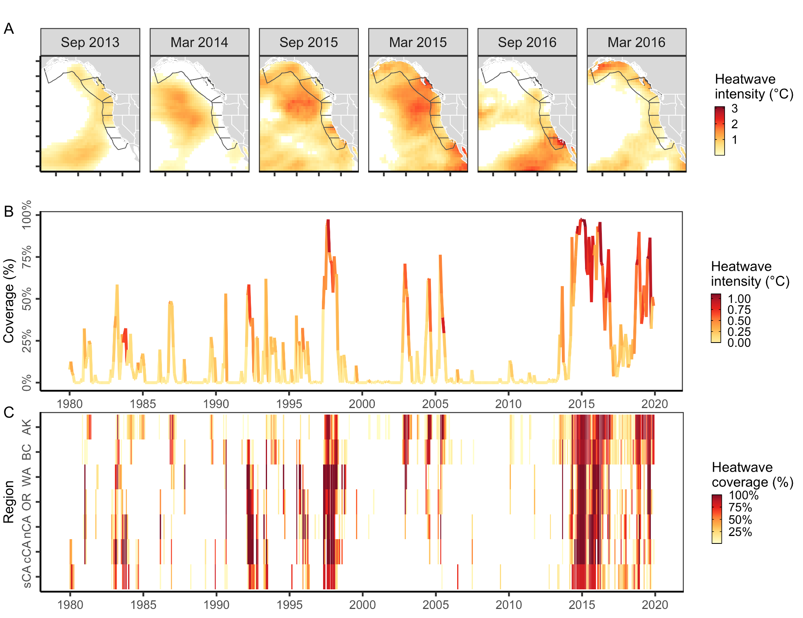**Figure 1.** History of marine heatwaves on the U.S. and Canada West Coast based on analysis of the COBE Sea Surface Temperature (SST) dataset [(Ishii et al., 2005)](https://www.zotero.org/google-docs/?KgwIet). In **(A),** gray lines indicate the Exclusive Economic Zones of southern (sCA), central (cCA), and northern California (nCA), Oregon (OR), Washington (WA), British Columbia (BC), and the Gulf of Alaska (AK). The lower panels show the history of marine heatwaves **(B)** across these seven regions and **(C)** within each of the seven regions. Heatwave conditions were identified as temperatures above the 90% of the historical climatology (1980-2010) for a given month and raster cell [(Hobday et al., 2016)](https://www.zotero.org/google-docs/?iZrA1k); thus, heatwave intensity represents the difference between the observed temperature and the 90% heatwave threshold. In **(B)**, heatwave intensity is averaged across all cells experiencing heatwave conditions.

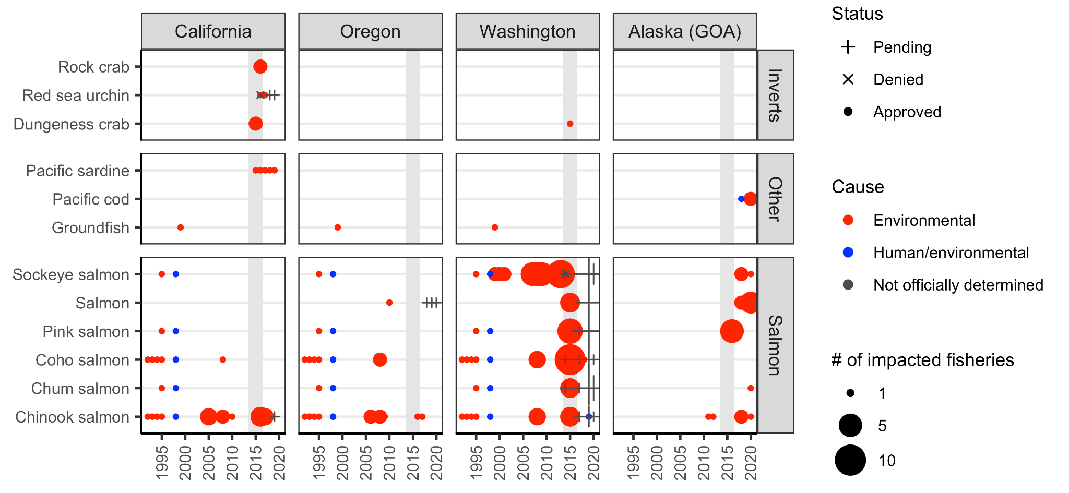

**Figure 2.** History of U.S. federal fisheries disaster declarations on the West Coast from 1989-2020 based on the database of [(L. Bellquist et al., 2021)](https://www.zotero.org/google-docs/?k8iL7a). Gray shading indicates years of the 2014-16 marine heatwave. Disaster declarations for Alaska fisheries occurring outside the Gulf of Alaska (GOA) are excluded.

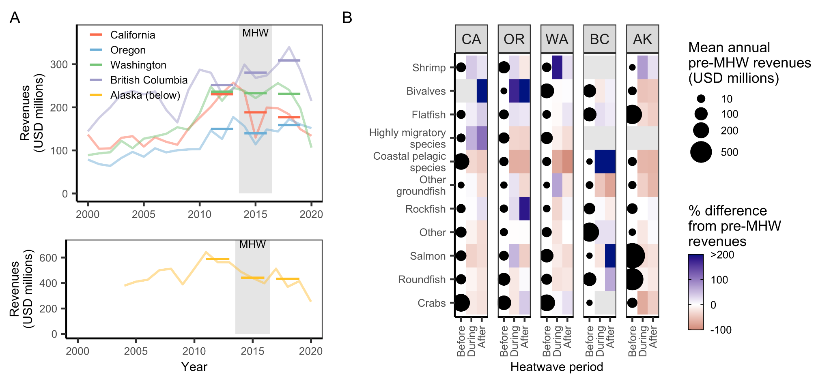**Figure 3.** Commercial fisheries revenues by **(A)** state and **(B)** state and management group before, during, and after the 2014-16 marine heatwave (MHW). In **(A)**, light lines indicate time series of total annual revenues and dark lines indicate the mean total annual revenue for years before (2011-13), during (2014-16), and after (2017-19) the heatwave. In **(B)**, the size of the points plotted in the “before” column indicate mean annual revenues during the years before the heatwave and the colors plotted in the “during” and “after” columns indicate the percent change in revenues relative to the years before the heatwave. Management groups are vertically ordered from greatest losses (bottom) to the greatest gains (top) in revenues during the heatwave averaged across states.

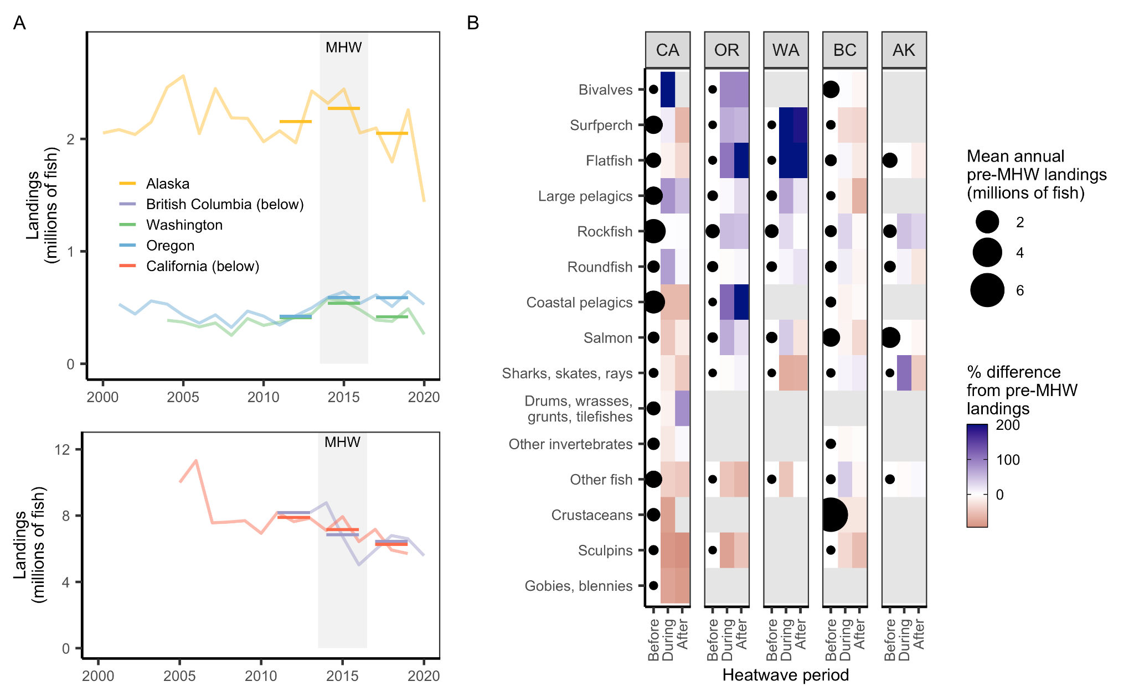**Figure 4.** Recreational fisheries landings by **(A)** state and **(B)** state and taxonomic group before, during, and after the 2014-16 marine heatwave (MHW) based on multiple recreational landings databases. In **(A)**, light lines indicate time series of total annual landings and dark lines indicate the mean total annual landings for years before (2011-13), during (2014-16), and after (2017-19) the heatwave. In **(B)**, the size of the points plotted in the “before” column indicate mean annual landings during the years before the heatwave and the colors plotted in the “during” and “after” columns indicate the percent change in revenues relative to the years before the heatwave. Taxonomic groups are vertically ordered from greatest losses (bottom) to the greatest gains (top) in revenues during the heatwave averaged across states.

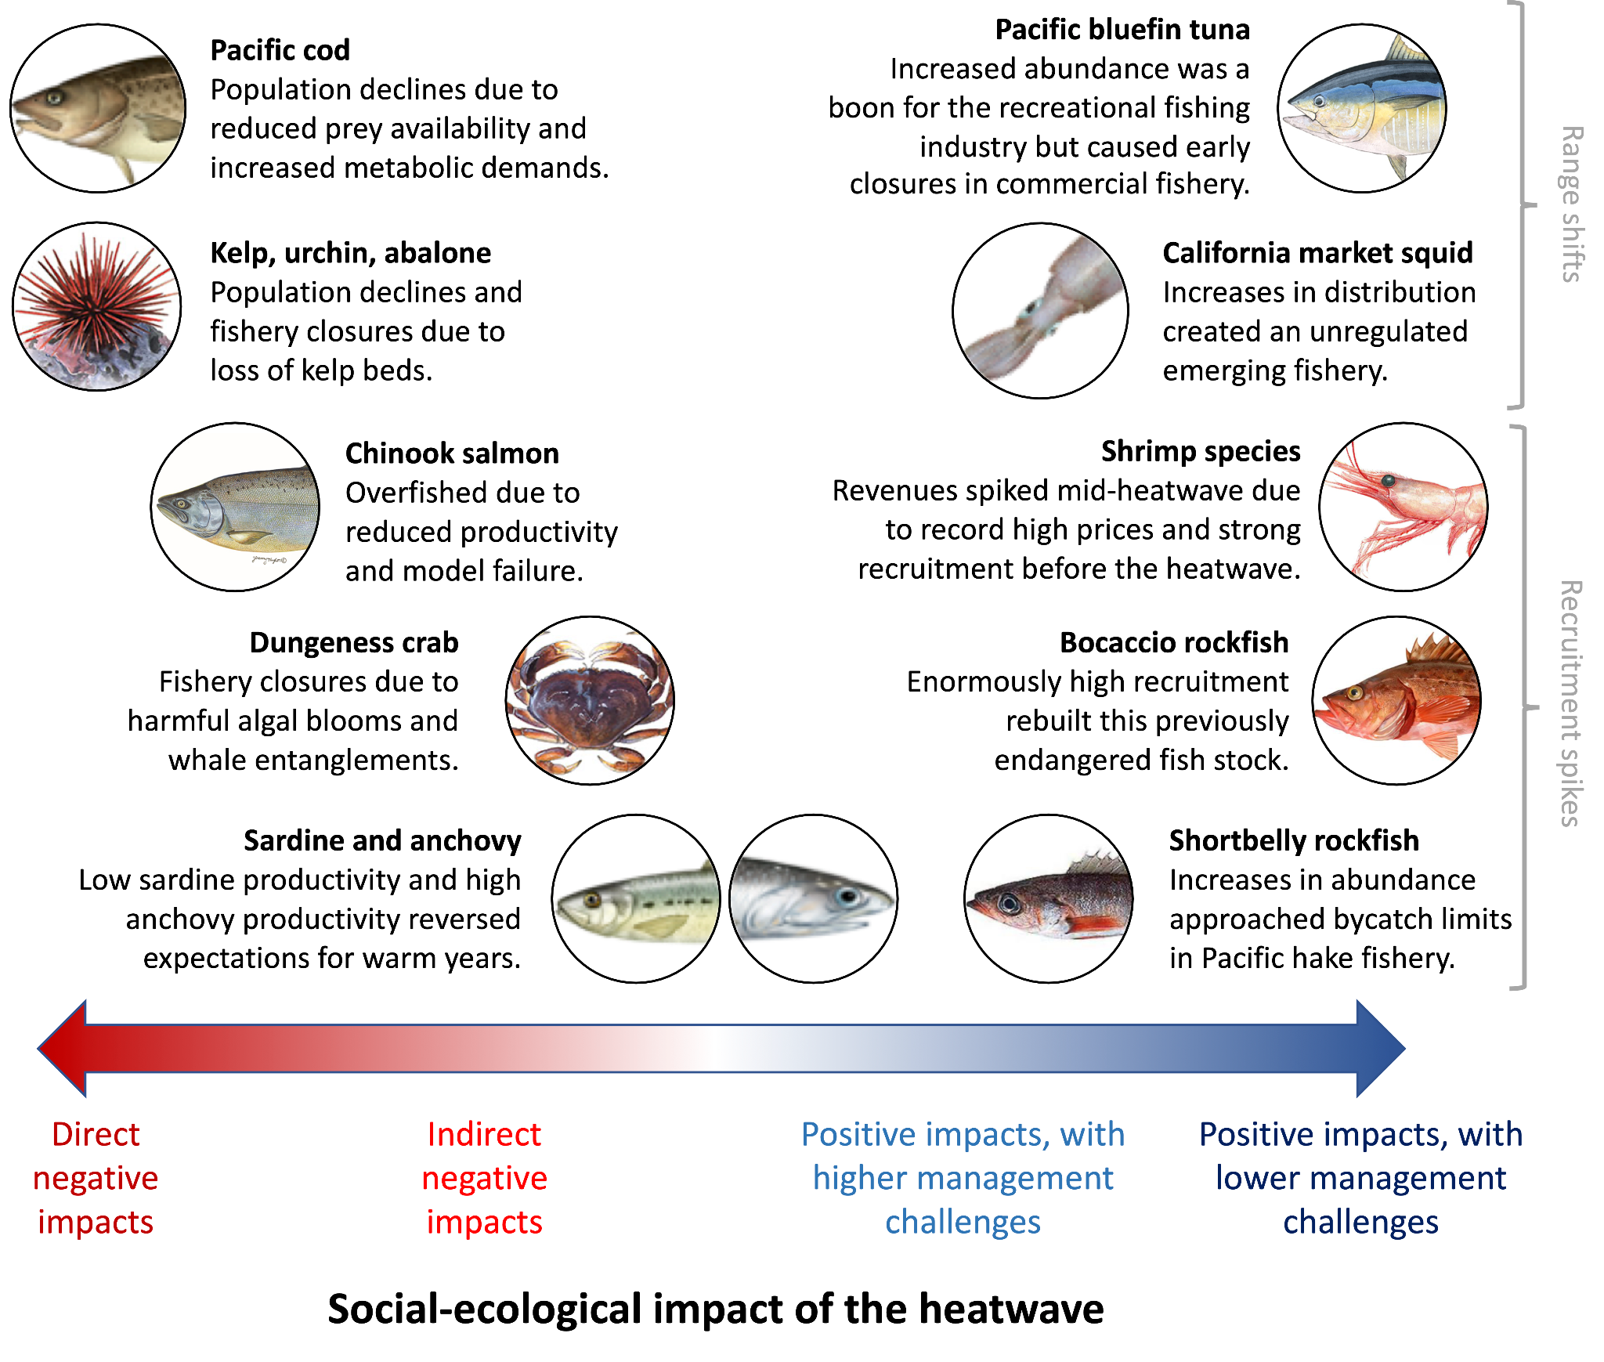**Figure 5.** Case studies evaluated in this paper. Case studies were selected to illustrate instructive examples of West Coast fisheries that experienced either positive (n=5) or negative (n=5) social-ecological impacts during the 2014-16 marine heatwave and to derive insights into improving monitoring, management, and adaptive capacity of communities to be more resilient to future heatwaves and climate change. Photo credits: NOAA (California market squid, northern anchovy, Pacific bluefin tuna, Pacific sardine, Pacific cod), CDFW (Chinook salmon, Dungeness crab, Pacific pink shrimp, red sea urchin), and WDFW (shortbelly rockfish).

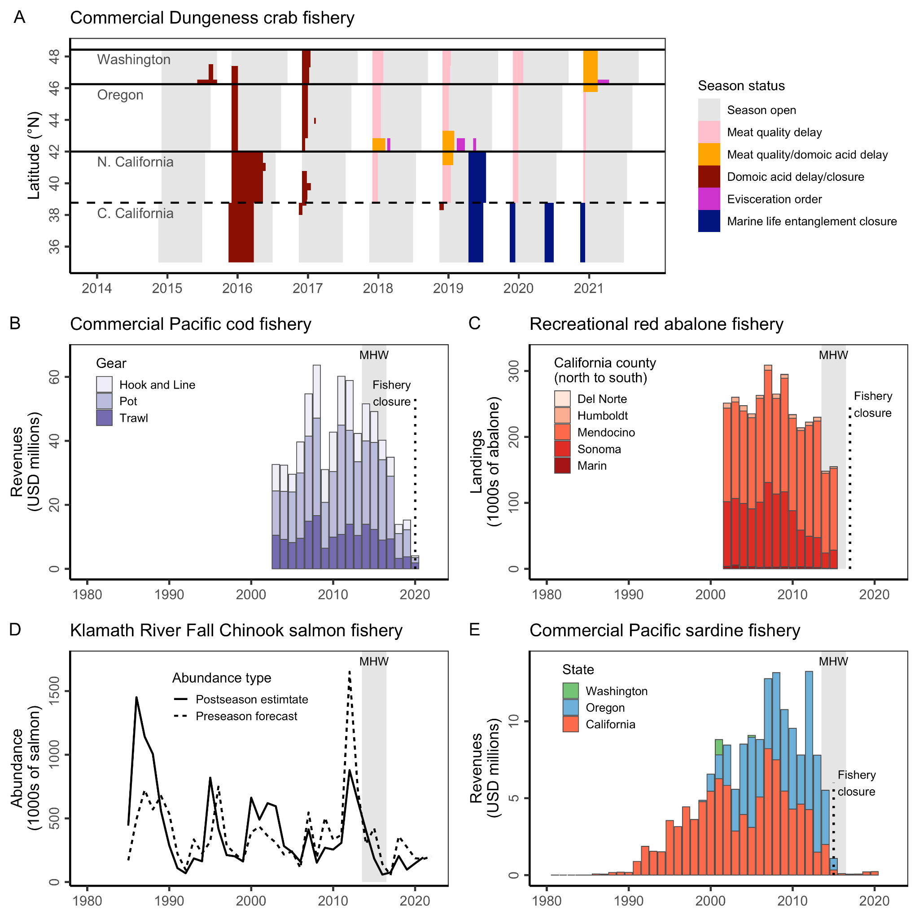**Figure 6.** Illustrations of some of the negative ecological and economic impacts of the 2014-16 marine heatwave. Panel **A** shows the history of closures to the commercial Dungeness crab fishery due to domoic acid contamination, whale entanglement, and meat quality. Panel **B** shows the collapse of the commercial Pacific cod fishery in the Gulf of Alaska after increased adult mortality and reduced juvenile recruitment during the heatwave. Panel **C** shows the collapse and closure of the recreational red abalone fishery during the heatwave. Panel **D** shows the collapse of the commercial Klamath River Fall Chinook salmon fishery after the marine heatwave and the contribution of overly optimistic model forecasts. Panel **E** shows the collapse of the commercial Pacific sardine fishery and its closure during the heatwave (see **Figure S3** for the increase in Northern anchovy documented in this case study).

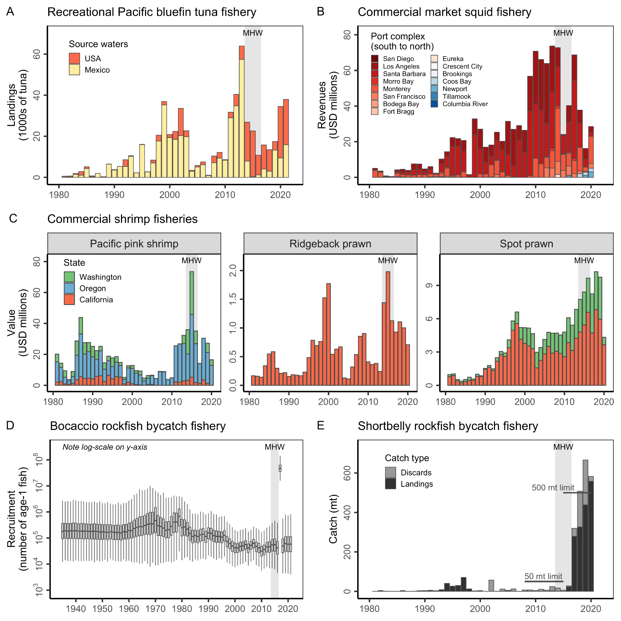

**Figure 7.** Illustrations of some of the positive ecological impacts of the 2014-16 marine heatwave. Panel **A** illustrates the increased availability of Pacific bluefin tuna in U.S. waters during the heatwave. Panel **B** illustrates the persistent northward shift of California market squid landings initiated during the heatwave. Red colors indicate port complexes in California and blue colors indicate port complexes in Oregon. Panel **C** illustrates the spike in revenues in the commercial Pacific pink shrimp and ridgeback prawn fisheries during the heatwave and the continued growth of the commercial spot prawn fishery through the heatwave. Panel **D** illustrates how the enormous spike in British Columbia bocaccio recruitment is projected to lead to the rebuilding of this endangered stock. In the boxplots, the solid line indicates the median, the box indicates the interquartile range (IQR; 25th to 75th percentiles), the whiskers indicate 1.5 times the IQR. Note the log-scale. Panel **E** illustrates the explosion in shortbelly rockfish bycatch following anomalous recruitment during the heatwave.

## Supplemental Information

This paper compiles several datasets to illustrate impacts of the 2014-16 marine heatwave on fisheries of the U.S. and Canada West Coast. We describe the compilation of these datasets below.

**Sea surface temperature data (Figure 1)**

The sea surface temperature data were obtained from the the COBE Sea Surface Temperature (SST) dataset [(Ishii et al., 2005)](https://www.zotero.org/google-docs/?QhSj1H), which provides monthly SST data on a globally complete 1°x1° grid from 1850-present based on an interpolation of in-situ and satellite-derived SST observations.

**Federal fisheries disaster data (Figure 2)**

The federal fisheries disaster data were obtained from Bellquist et al. (2021). These data describe information on every U.S. federal fisheries disaster declaration occurring from 1989-2020, including information on the fishery impacted, the cause of the disaster, the amount of relief money requested and awarded, and other relevant information.

**Commercial revenues data (Figures 3 & S1)**

We used annual statewide fisheries revenue data to evaluate impacts of the heatwave on commercial fisheries. To create this dataset, we combined data from a few sources. We used annual revenue data from the PacFIN database for the U.S. West Coast (California, Oregon, and Washington) and data provided directly from NOAA for the Gulf of Alaska. We were unable to use the AKFIN database (i.e., the equivalent of PacFIN for Alaska) for Alaska because the AKFIN database only includes crabs and groundfish (i.e., it is less comprehensive), is not species-specific (i.e., it is more generic), and does not separate the Gulf of Alaska from the Bering Sea and Aleutian Islands regions. We focus on the Gulf of Alaska region because this was the region impacted by the 2014-16 marine heatwave. We used annual revenue data provided directly by Fisheries and Oceans Canada (DFO) for British Columbia.

**Recreational landings data (Figures 4 & S2)**

We used estimates of annual statewide fisheries landings (i.e., number of retained fish) to evaluate impacts of the heatwave on recreational fisheries. To create this dataset, we combined data from a few sources. We used estimates of annual landings from the RecFIN database for the U.S. West Coast (California, Oregon, and Washington) and from the ADFG website for the Gulf of Alaska. However, the RecFIN data does not include catches of highly migratory species in California’s for-hire (Commercial Passenger Fishing Vessel or CPFV) fleet. Thus, we used data from the CDFW Landings Reports for these species. We used the ADFG database for Alaska because the AKFIN database does not include recreational landings estimates. Although the NOAA FOSS database includes estimates of recreational landings by state, these estimates have been transformed into biomass (pounds) and are thus less representative of the original data. Furthermore, they do not include recreational landings estimates for Alaska.

**Case study time series data**

*Dungeness crab management history (Figure 6A)*

We obtained the spatial-temporal history of the Dungeness crab fishery from [(Free, Moore, et al., 2022)](https://www.zotero.org/google-docs/?7zhUaa). These data describe the location and duration of every closure (or evisceration order) in the West Coast Dungeness crab fishery from 2014-2021.

*GOA Pacific cod revenues data (Figure 6B)*

We obtained time series of commercial Gulf of Alaska (GOA) Pacific cod fisheries revenues by gear and subarea from the AKFIN database.

*Red abalone landings data (Figure 6C)*

We obtained time series of recreational red abalone landings estimates by county from a CDFW report [(CDFW, 2015)](https://www.zotero.org/google-docs/?TTGbfm). CDFW estimated these values using abalone “report cards” (i.e. creel survey) and telephone surveys [(Kalvass & Geibel, 2006)](https://www.zotero.org/google-docs/?lBKE4W).

*Klamath River Fall Chinook escapement forecasts and observations (Figure 6D)*

We obtained time series of Klamath River Fall Chinook salmon pre-season escapement forecasts and post-season escapement observations from the 2022 pre-season report [(PFMC, 2022)](https://www.zotero.org/google-docs/?wpqXsW). Escapement represents the number of salmon that escaped fishing and returned upriver.

*Pacific sardine revenues data (Figure 6E)*

We obtained time series of commercial Pacific sardine fisheries revenues by state from the PacFIN database [(PSMFC, 2021)](https://www.zotero.org/google-docs/?Z3BZKD), as compiled in the CALFISH database [(Free, Vargas Poulsen, et al., 2022)](https://www.zotero.org/google-docs/?ZzzewS).

*Pacific bluefin tuna landings data (Figure 7A)*

We obtained time series of Pacific bluefin tuna landings by source waters (U.S. or Mexico) by California’s recreational for-hire fleet from the California Marine Logbook System (MLS). The data query was submitted and processed by a co-author who is a CDFW employee.

*Market squid revenues data (Figure 7B)*

We obtained time series of commercial market squid fisheries revenues by port complex from the PacFIN database [(PSMFC, 2021)](https://www.zotero.org/google-docs/?IKrkWu), as compiled in the CALFISH database [(Free, Vargas Poulsen, et al., 2022)](https://www.zotero.org/google-docs/?skL8eQ).

*Bocaccio recruitment estimates (Figure 7D)*

We obtained time series of Bocaccio rockfish recruitment estimates from the first author of the most recent bocaccio rockfish stock assessment [(DFO, 2021)](https://www.zotero.org/google-docs/?Lzxykj).

*Shortbelly rockfish bycatch data (Figure 7E)*

We obtained time series of shortbelly rockfish landings and discard estimates from the Groundfish Expanded Mortality Multiyear (GEMM) [(Somers et al., 2020, 2021)](https://www.zotero.org/google-docs/?Gh3lxw).

*Northern anchovy index of abundance data (Figure S3)*

Larval anchovy time series is from the CalCOFI spring survey. Young of the year time series is from the Rockfish Recruitment and Ecosystem Assessment Survey (RREAS) in southern California [(Thompson, Bjorkstedt, et al., 2022)](https://www.zotero.org/google-docs/?SRlloD).

*Pacific bluefin tuna trophy size fish data (Figure S4)*

We obtained time series of trophy size Pacific bluefin tuna reported in the “Whoppers of the Week” section of Western Outdoor News from 1968-2019 from [(L. F. Bellquist et al., 2016)](https://www.zotero.org/google-docs/?bUpgpI).

### 

**Table S1.** Lessons for improving monitoring, management, and adaptive capacity.

|  |  |  |
| --- | --- | --- |
| **Principle** | | **Example** |
| ***For improved monitoring*** | |  |
| 1 | Strategically enhance the spatial-temporal scale of monitoring to promote dynamic management that reduces tradeoffs among competing objectives | Increased spatial-temporal monitoring of harmful algal blooms and biotoxin contamination can protect public health while minimizing impacts on fishing opportunities |
| 2 | Target monitoring to understand drivers of sudden shifts in productivity/distribution that have occurred during past heatwaves and use this knowledge to better prepare for future heatwaves | Targeted monitoring is needed to resolve (a) the relationship between local HMS availability and stockwide abundance, (b) reversals in long-believed relationships between the environment and CPS fisheries productivity, and (c) earlier detection of heatwave-driven shifts in abundance/distribution. |
| 3 | Develop tools for rapidly processing, visualizing, and disseminating raw monitoring data to democratize and accelerate the rate at which “unknown unknowns” and other surprises are detected and responded to | The standardized summaries of available fisheries-dependent and fisheries-independent data for Canadian Pacific groundfish (Anderson et al., 2019) provide a useful template for such tools. |
| 4 | Use technology that makes monitoring cheaper or partnerships that make monitoring more efficient to reduce or maintain costs | Citizen/community science programs can integrate new tools to achieve cheaper data collection at scale |
| ***For improved management*** | |  |
| 1 | Broaden co-management systems that leverage stakeholder knowledge, lower monitoring/management costs, and empower diverse voices | The inclusion of fishers in the management of whale entanglement risk in the CA Dungeness crab fishery assisted in identifying/implementing feasible, equitable, and effective management actions. |
| 2 | Increase the agility and flexibility of fisheries management institutions and procedures to expedite effective responses to surprises | This could involve establishing (a) alternative procedures for updating bycatch quotas in response to unexpectedly high recruitment events or (b) plans for evaluating and managing rapidly emerging fisheries that introduce novel conflicts between fisheries or between economic/conservation goals. |
| 3 | Enhance the adaptiveness or robustness of fisheries management to the impacts of heatwaves and climate change | This could involve (a) accounting for shifting productivity by incorporating climate variables into stock assessments and/or (b) designing harvest control rules that are robust to climate change. |
| 4 | Use climate-linked management strategy evaluation to compare the performance of alternative management strategies under climate change to quantitatively inform management decisions | Apply marine heatwave scenarios, particularly for short-lived species (e.g., CPS), species that experience critical life history bottlenecks (e.g., aggregating or diadromous species), or uniquely vulnerable species (e.g., red abalone). |
| ***For improved adaptive capacity*** | |  |
| 1 | Broaden co-management systems that leverage stakeholder knowledge, lower monitoring/management costs, and empower diverse voices  *(note: this is also a lesson for improved monitoring and management)* | NOAA-funded research conducted with the recreational fishing industry facilitated the development of descending devices that reduce rockfish discard mortality. Led by the recreational fishing industry, these devices are now mandated in recreational fisheries coastwide (voluntary in California). |
| 2 | Bolster policies that promote livelihood diversification to buffer fishing communities against negative climate impacts | Easing access to fishing permits can promote target species diversification and buffer revenues against heatwaves, climate change, and other market shocks. |
| 3 | Enhance permit programs that allow experimentation to accelerate innovation in climate-ready strategies | Exempted Fishing Permits with good experimental design could, for example, be leveraged to stimulate an expanded purple sea urchin fishery that enhances kelp reforestation, design whale-safe fishing gear or practices that jointly prevent entanglements and fishery closures, or develop new fisheries-dependent data streams that enhance adaptive management. |
| 4 | Enhance programs that provide economic relief in response to negative environmental impacts to improve the resilience of fishing communities to climate change | This could involve (a) reforming disaster relief programs to be more timely, accurate, and equitable in their assessment and distribution of disaster relief and/or (b) developing fisheries insurance programs that smooth risk, mitigate losses, and/or incentivize climate-resilient actions. |

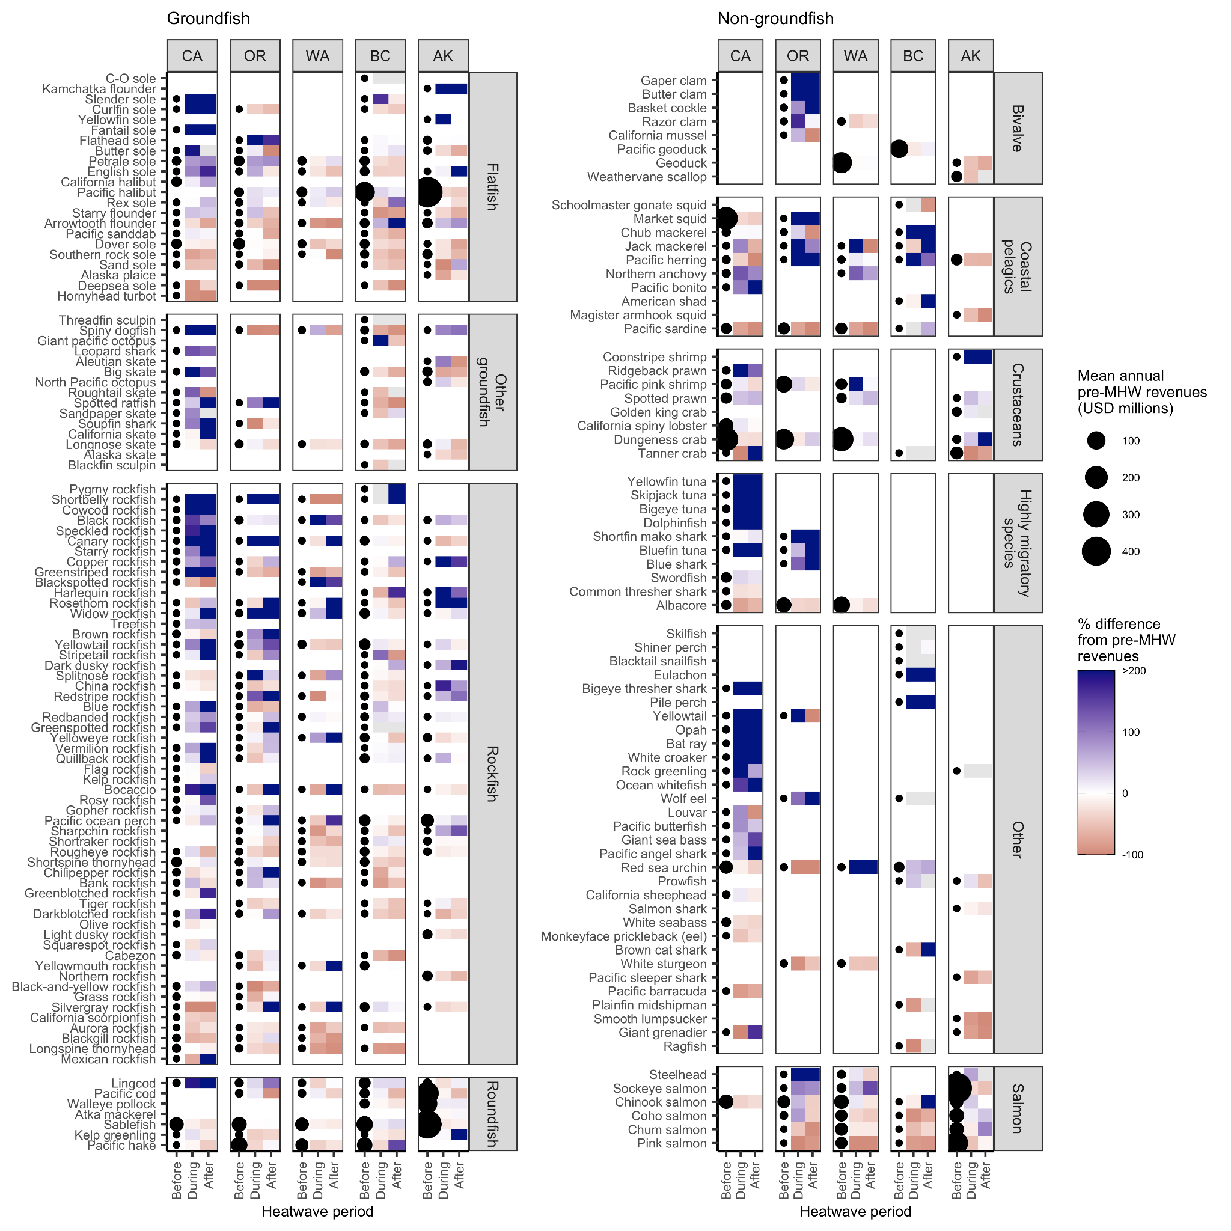

**Figure S1.** Commercial fisheries revenues before the 2014-16 marine heatwave and the percent change in revenues during and after the heatwave by state, management group, and species. Species (rows) are grouped by management group and are vertically ordered from greatest losses (bottom) to the greatest gains (top) in revenues during the heatwave averaged across states. The size of the points plotted in the “before” column indicate mean annual revenues during the years before the heatwave and the colors plotted in the “during” and “after” columns indicate the percent change in revenues relative to the years before the heatwave.

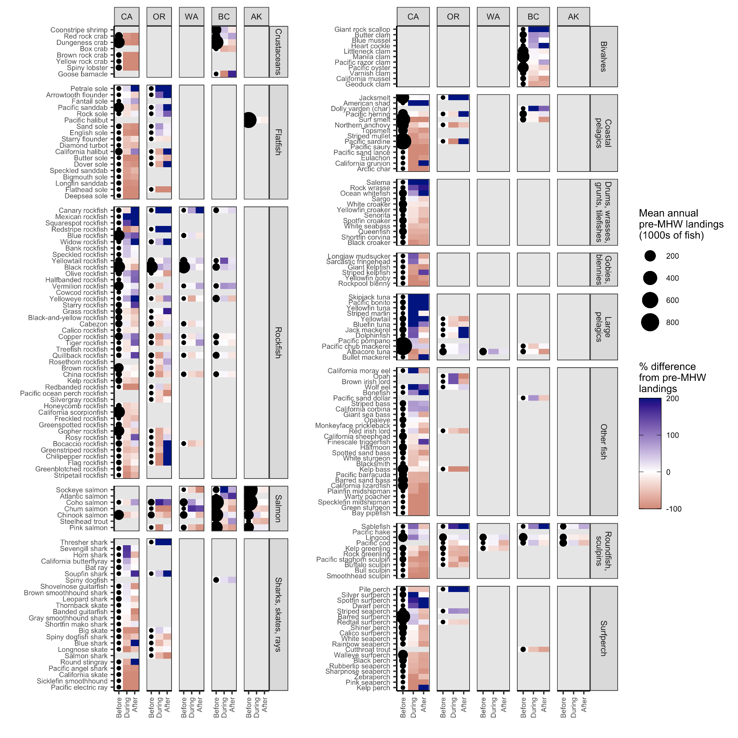**Figure S2.** Recreational fisheries landings (number of retained individuals) before the 2014-16 marine heatwave and the percent change in landings during and after the heatwave by state, management group, and species based on multiple recreational landings databases. Species (rows) are grouped by taxonomic group and are vertically ordered from greatest losses (bottom) to the greatest gains (top) in landings during the heatwave averaged across states. The size of the points plotted in the “before” column indicate mean annual landings during the years before the heatwave and the colors plotted in the “during” and “after” columns indicate the percent change in revenues relative to the years before the heatwave.

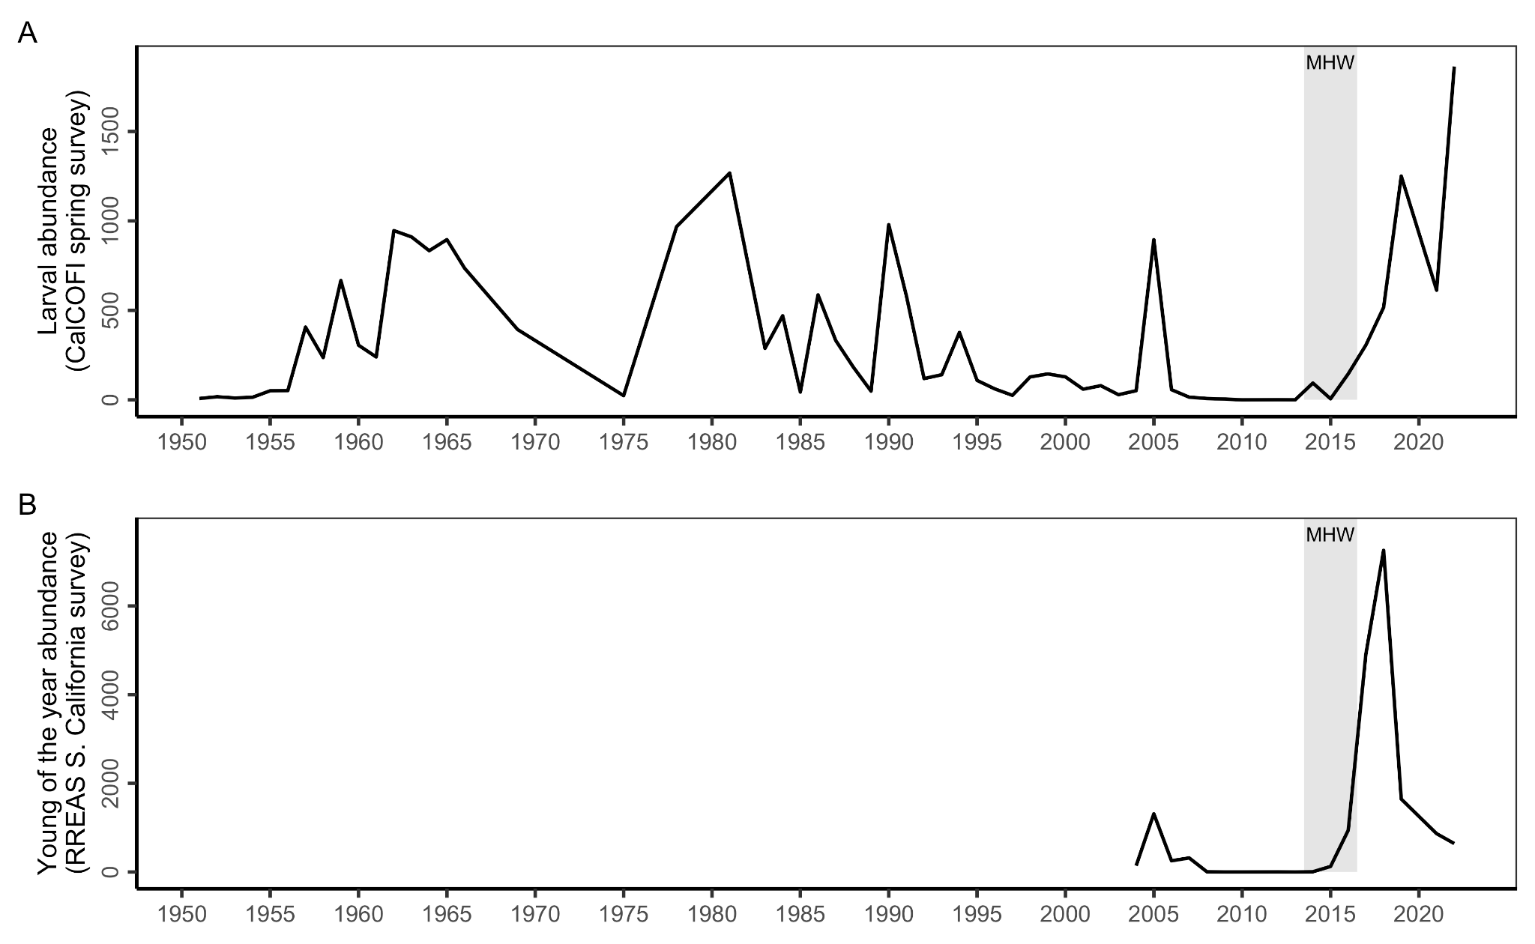**Figure S3.** The mean abundance of Northern anchovy **(A)** larvae (number under 10 m2) and **(B)** young-of-the-year in southern California (number per catch) . Larval anchovy time series is from the CalCOFI bongo net spring survey. Young of the year time series is from the summer midwater trawlRockfish Recruitment and Ecosystem Assessment Survey (RREAS) in southern California.

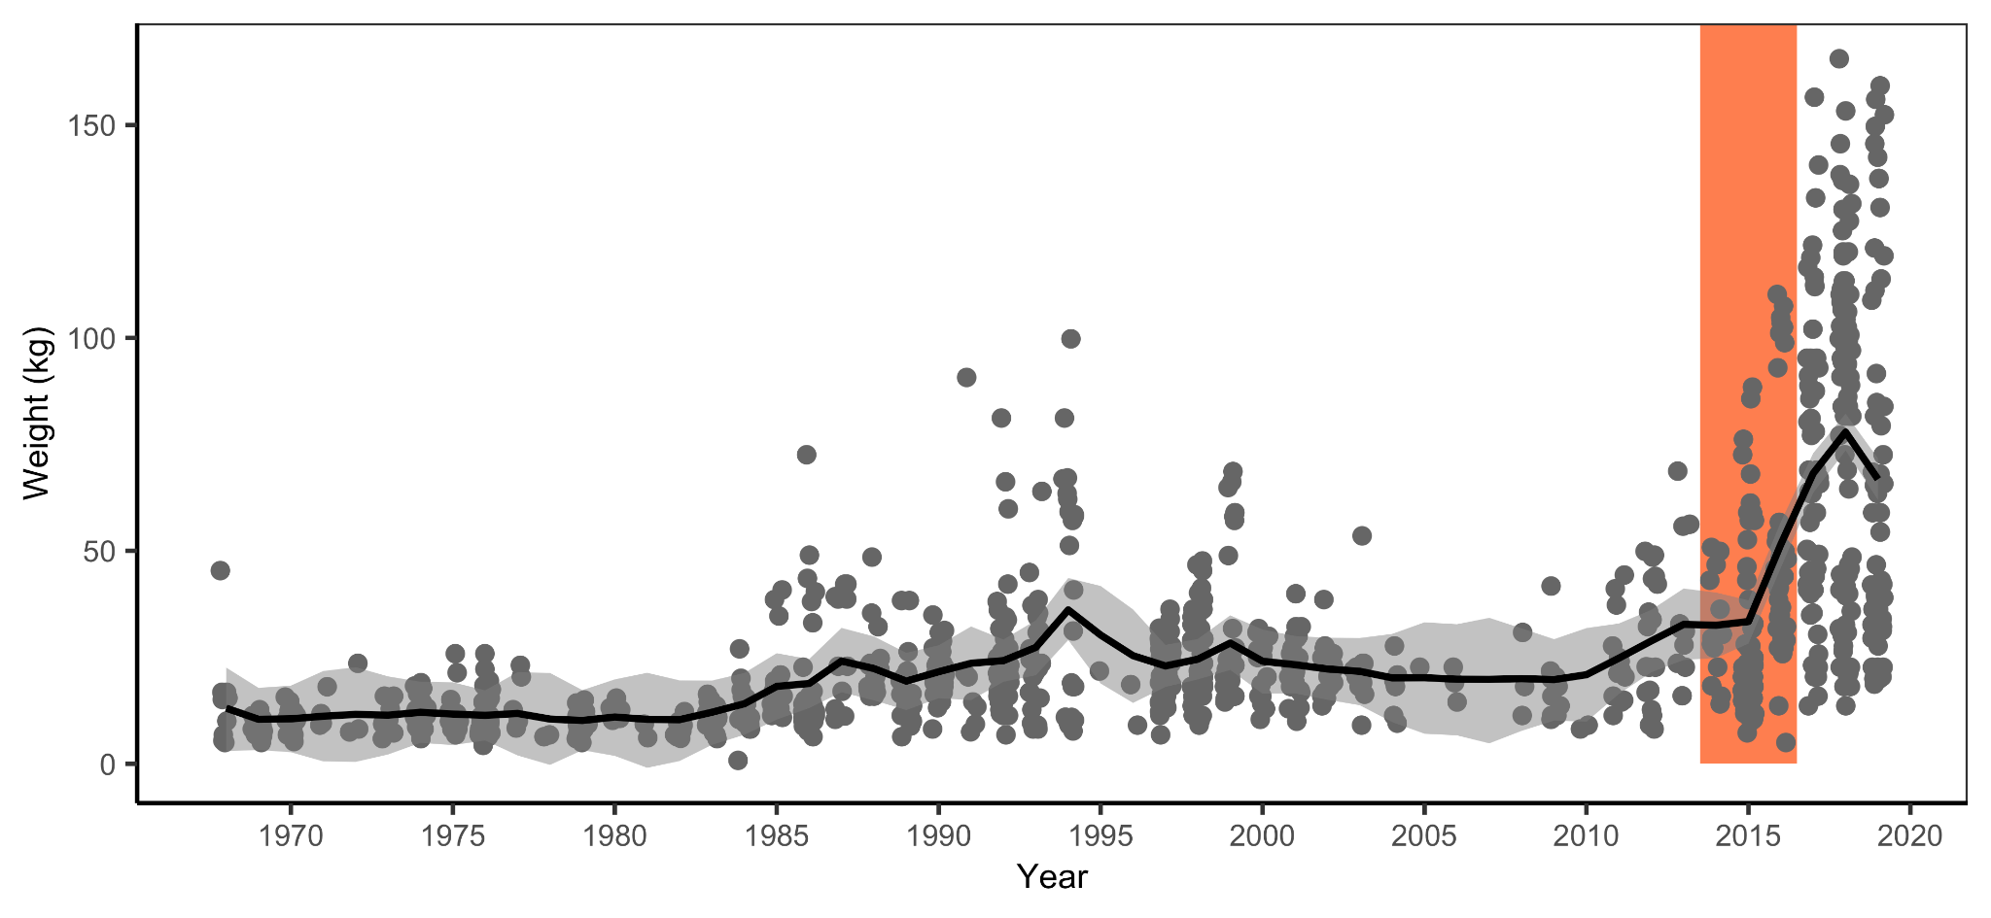**Figure S4.** Time series of trophy size Pacific bluefin tuna reported in the “Whoppers of the Week” section of Western Outdoor News from 1968-2019. The vertical orange rectangle illustrates the 2014-16 marine heatwave. The black line and shading indicate the median and 95% confidence interval of a state-space model fit to the data. The data and modeling framework are an extension of that published in [(L. F. Bellquist et al., 2016)](https://www.zotero.org/google-docs/?JLSfjY).